Plan of Service User Manual

A step by step navigational process

January 2014

Prepared by FEi Systems

Table of Contents

1 Getting Started 1

1.1 Client Profile Strengths and Goals 1

1.1.1 Client Profile Strengths 1

1.1.2 Client Profile Goals 1

1.2 InterRAI Result CAPS 2

2 Tutorials 3

2.1 Accessing the New Plan of Service Module 3

2.2 Plan of Service 4

2.2.1 List Plans of Service 4

2.2.2 Add/Edit Plan of Service 4

2.2.3 Plan of Service Pending Lead Review 40

2.2.4 Clarification Request on Plan of Service 41

2.2.5 Plan of Service Pending POS Unit Decision 42

2.2.6 Plan of Service Decisions 43

2.2.7 Converting a Provisional Plan of Service 45

2.2.8 Print Plan of Service 48

2.2.9 Revise Plan of Service 48

2.2.10 Active vs. Inactive Plan of Service 50

2.2.11 Inactivate a Plan of Service 51

2.2.12 POS Unit Staff Assignment 52

2.2.13 Plan of Service My Lists 53

3 Appendix 54

3.1 Plan of Service Connections with Other Modules 54

# Getting Started

This manual gives an in depth navigational walk through of the Plan of Service process. It begins by showing the process for navigating to the new Plan of Service module in LTSS. The tutorials will then step through each section of the Plan of Service and explain to the user the purpose and functions within each section. Also, within each section the Tutorials will explain the in-depth business rules and interconnections between the Plan of Service and other parts of LTSS.

## Client Profile Strengths and Goals

### Client Profile Strengths

A client’s strengths can be managed through the Client Profile at any time. From the Client Profile authorized users will be able to list all of the strengths of the client. In order to manage the strengths of the client click the Manage link as seen in the figure below. When a Plan of Service is created and prior to having a decision made, all client strengths from the Client Profile will be pulled directly in to the Plan of Service. Any change made to a strength through the Client Profile will be reflected inside the Plan of Service where that strengths exists prior to a decision being made on the Plan of Service.

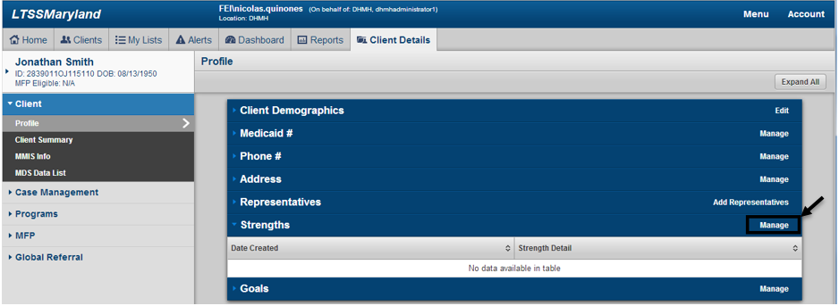

### Client Profile Goals

A client’s goals can be managed through the Client Profile at any time. From the Client Profile authorized users will be able to list all of the goals of the client. In order to manage the goals of the client click the Manage link as seen in the figure below. When a Plan of Service is created and prior to having a decision made, all client goals with Progress = Not Begun and In Progress from the Client Profile will be pulled directly in to the Plan of Service. Any change made to a goal through the Client Profile will be reflected inside the Plan of Service where that goal exists prior to a decision being made on the Plan of Service.

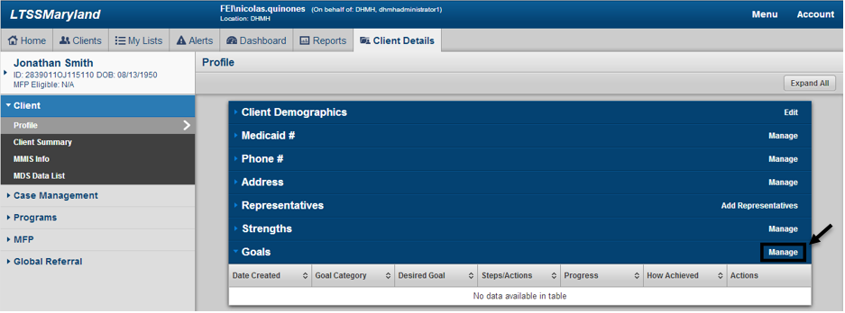

## InterRAI Result CAPS

Each time an InterRAI HC MD Assessment is completed for a client, a list of Triggered CAPS are produced on the results page for that InterRAI Assessment. The Triggered CAPS from the client’s most recent submitted InterRAI Assessment will be pulled directly in to the Plan of Service upon creation to represent part of the current risks for the client. The figure below shows a sample InterRAI Assessment Results page, with examples of the Triggered CAPS that could be pulled in and used for a Plan of Service. The tutorials section on the Risks section of the Plan of Service will provide more details on how the Triggered CAPS are used for the Plan of Service.

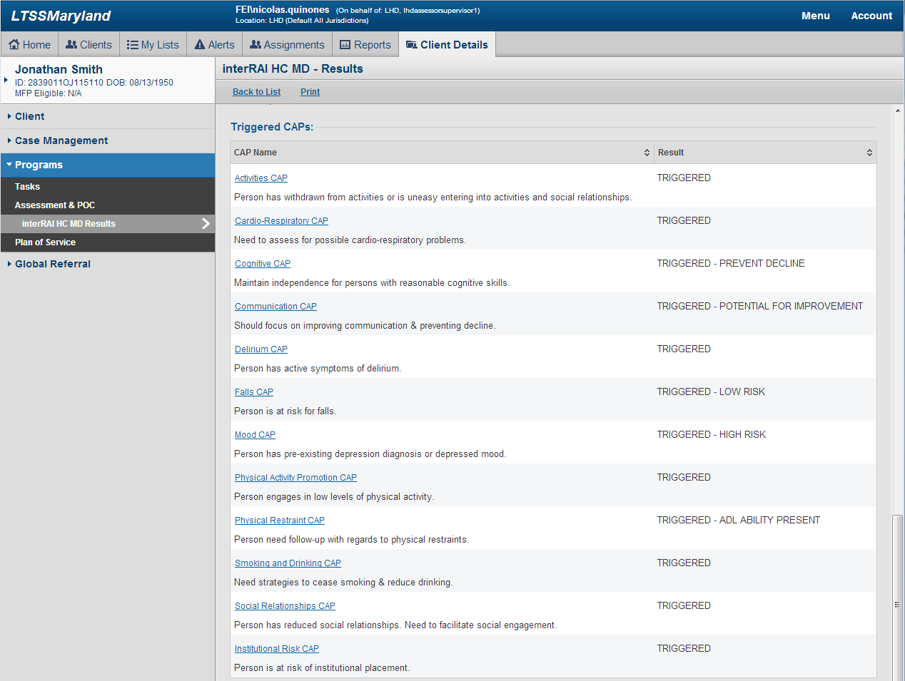

# Tutorials

## Accessing the New Plan of Service Module

The first step in accessing the Plan of Service is to search for the client under the Clients tab in LTSS. After entering search criteria click the Cases button in order to produce a list of clients that match the search criteria. After identifying the client record you wish to access, click the Client Summary link as shown in the figure below.

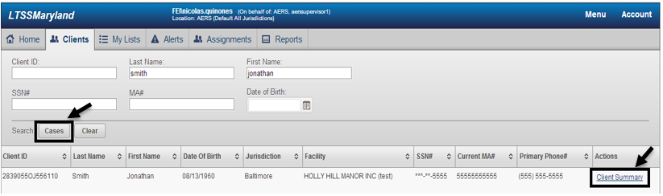

After clicking the Client Summary link, the user will be taken to the Client Summary page of the respective client selected. To access the Plan of Service module from the Client Summary page, click on the Programs tab in the left hand navigation and then select Plan of Service under the submenu as seen in the figure below.

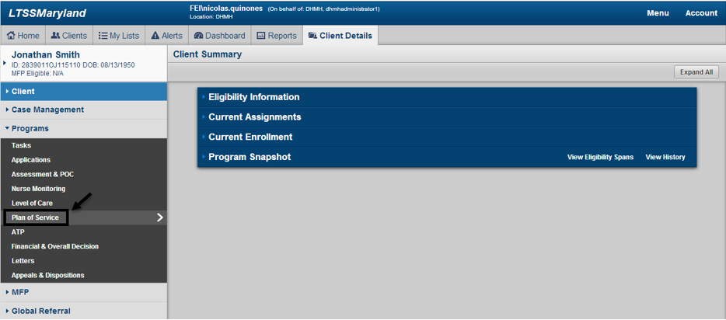

## Plan of Service

What follows is a step by step process through the creation and workflow associated to the Plan of Service. Each major section and/or function for the Plan of Service will represent one tutorial within this manual.

### List Plans of Service

After accesing the Plan of Service module a list of Plans of Service across the entire history of the client will be available. This will allow authorized users to see a full history of a clients Plans of Service across all waivers/programs.

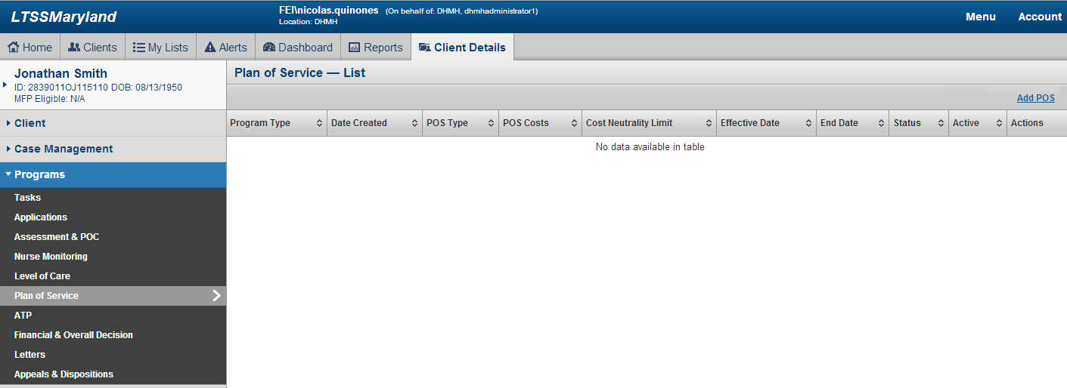

### Add/Edit Plan of Service

To add a Plan of Service click the Add POS link in the upper right hand corner of the Plan of Service List page as seen in the figure below.

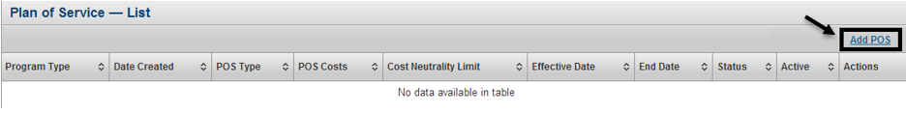

#### Overview Information

When clicking the Add POS link, LTSS will take the user to the Overview Information section of the Plan of Service. In order to actually create a shell of an entire Plan of Service the user must first complete and save the Overview Information section of the POS. The Overview Information section contains basic client information, the address to receive services and specific program and plan of service information as seen in the figure below. In addition, this section will display the clients current Support Planning Agency at the time the Plan of Service is being developed. Once a decision is made on a Plan of Service, the clients Support Planning Agency at the time will be locked in to that specific Plan of Service. Critical information related to the Plan of Service is housed in the Overview portion of this section of the POS. The Program Type selection will drive the available services within the POS. CO and ICS will contain the full set of services available in LTSS, while CFC will only contain a subset of those services and MAPC will contain a subset of the services available to CFC. In addition, the selection of a POS Type will drive what information is required within the Plan of Service as well as the workflow for the Plan of Service. For example, when POS Type is set as Provisional, the following information is optional in order to submit and have a decision made on the Plan of Service: Address to Receive Services, POS Effective Date, and Provider information pertaining to individual services in the POS. Upon completion of the required fields, click the Save button to generate the shell of the Plan of Service. It is important to note that a Provisional POS can never be considered Active. In order to make a Provisional POS Active it must go through a conversion process which will be detailed in a later tutorial in this manual. Users should note that throughout all of LTSS, all fields highlighted in yellow and marked with one red star indicate that the field is required in order to save the form/section. All fields marked with two stars indicate that the field is required in order to submit the overall form and all other fields are optional. Certain information throughout the Plan of Service will display as read only information to the user as this information is pre-populated or calculated based on other information provided in LTSS for the client. In most situations this type of information is pulled from either the Client Profile or from other forms completed for the client.

When clicking the Add POS link, LTSS will take the user to the Overview Information section of the Plan of Service. In order to actually create a shell of an entire Plan of Service the user must first complete and save the Overview Information section of the POS. The Overview Information section contains basic client information, the address to receive services and specific program and plan of service information as seen in the figure below. In addition, this section will display the clients current Support Planning Agency at the time the Plan of Service is being developed. Once a decision is made on a Plan of Service, the clients Support Planning Agency at the time will be locked in to that specific Plan of Service. Critical information related to the Plan of Service is housed in the Overview portion of this section of the POS. The Program Type selection will drive the available services within the POS. CO and ICS will contain the full set of services available in LTSS, while CFC will only contain a subset of those services and MAPC will contain a subset of the services available to CFC. In addition, the selection of a POS Type will drive what information is required within the Plan of Service as well as the workflow for the Plan of Service. For example, when POS Type is set as Provisional, the following information is optional in order to submit and have a decision made on the Plan of Service: Address to Receive Services, POS Effective Date, and Provider information pertaining to individual services in the POS. Upon completion of the required fields, click the Save button to generate the shell of the Plan of Service. It is important to note that a Provisional POS can never be considered Active. In order to make a Provisional POS Active it must go through a conversion process which will be detailed in a later tutorial in this manual. Users should note that throughout all of LTSS, all fields highlighted in yellow and marked with one red star indicate that the field is required in order to save the form/section. All fields marked with two stars indicate that the field is required in order to submit the overall form and all other fields are optional. Certain information throughout the Plan of Service will display as read only information to the user as this information is pre-populated or calculated based on other information provided in LTSS for the client. In most situations this type of information is pulled from either the Client Profile or from other forms completed for the client.

A significant change to note is that during creation, a Plan of Service will only have a POS Effecitve Date, which essentially acts as the start date for the POS. A Plan of Service can now remain effective for an indefinite period of time. The only way a POS will receive a POS End Date is if it is either manually inactivated or if a new Plan of Service is Approved for the client. Both of these situations will be explained in greater detail in a later tutorial in this manual.

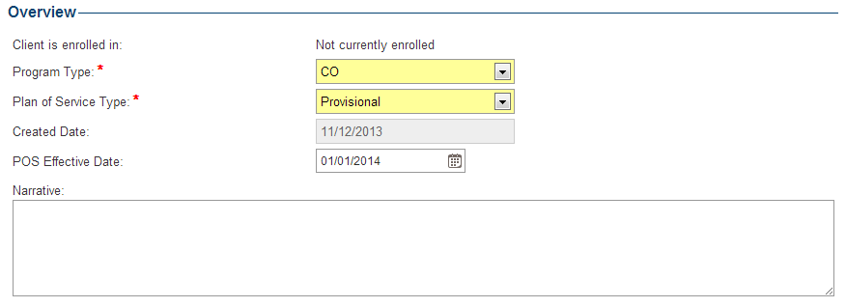

Upon saving the Overview Information section when adding a Plan of Service, the user will be taken to the Plan of Service Summary page as seen in the figure below. Once created, the Plan of Service enters a Status of In Progress. The Status of the POS determines which users have access to perform certain functions within that Plan of Service. Typically, an In Progress POS indicates that the POS is being developed by a support planner and has not yet been submitted for a team lead review. The Plan of Service Summary page will give the user a glimpse in to each section of the POS. As noted prior, each section that is marked with two stars indicates that the completion of the required field within that section is required in order to submit the overall Plan of Service. Each section of the Plan of Service is represented by one panel bar on the Plan of Service Summary page. In order to see summary details for an individual section the user can click on the specific panel bar to expand and see the contents within.

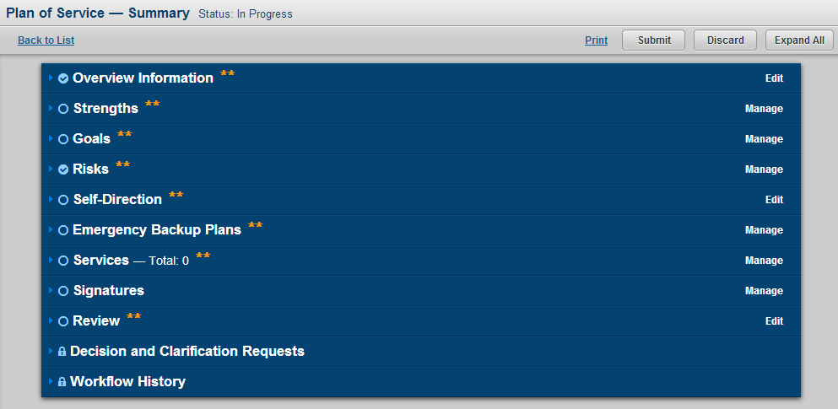

#### Strengths

By default the Strengths list within a Plan of Service that does not have a decision of Approve or Deny will contain all of the strengths listed in the Client Profile. After a decision is made on a Plan of Service the Strengths list within that Plan of Service will be locked in and will not change going forward in order to capture an accurate picture of the client strengths at the time a decision was made on the POS. Prior to a decision being made an authorized user can make updates to the strengths inside the POS by clicking the Manage link on the Strengths panel as seen in the figure below.

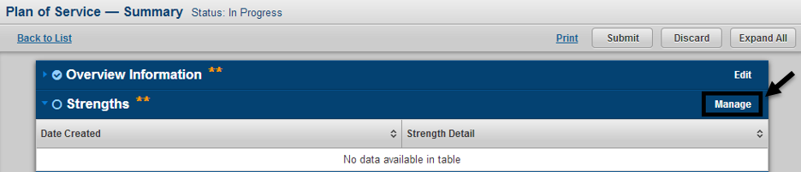

After clicking the Manage link the user will be taken to the Plan of Service Strengths page. From this page authorized users will be able to manage all aspects of strengths within the Plan of Service. New strengths can be added by filling in the required fields and clicking the Add Strength button as seen in the figure below. The user can also edit an existing Strength by clicking the Edit link as seen in the figure below.

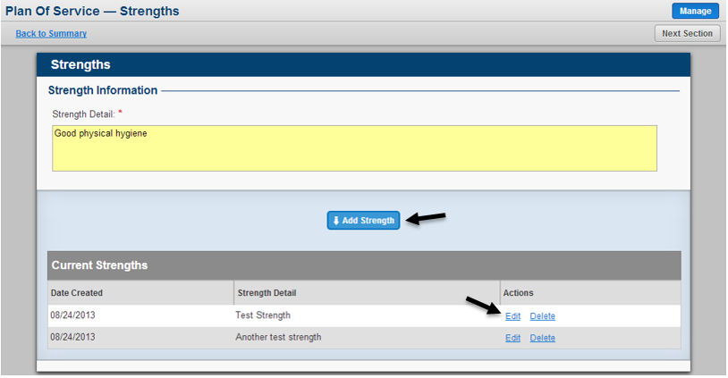

When clicking the Edit link the last saved content for that Strength will be pulled up for the user and will be available for modification. When selecting to edit a strength the specific strength being edited will be highlighted and marked accordingly inside the Current Strengths list at the bottom of the page. While in edit mode,the user can either choose to cancel making edits by clicking the Cancel button or can save any edits made by clicking the Save Changes button.

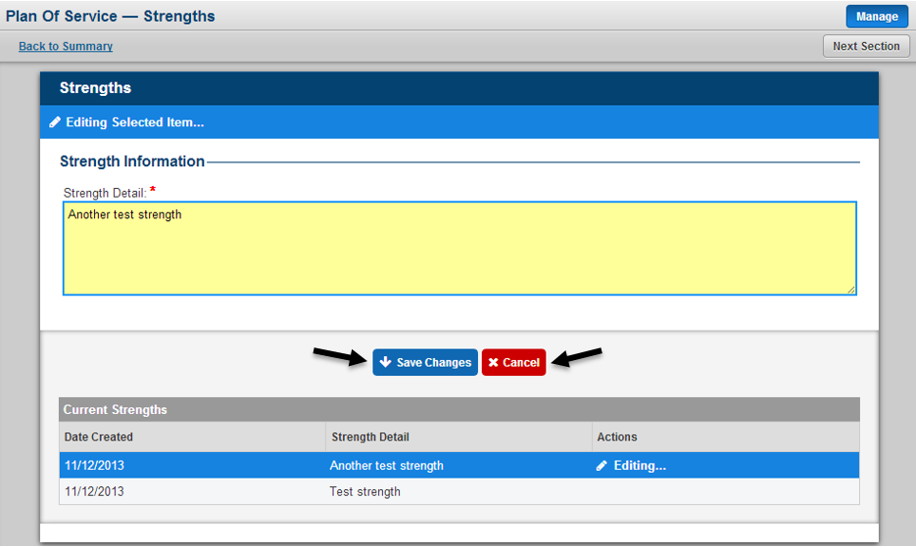

Users will also have the ability to Remove a Strength from within the Plan of Service. The removal of a strength from within the POS will be considered a soft delete, meaning that this will only remove this strengths reference from the specific POS and that the strength will still be manageable from the Client Profile Strengths list. In order to remove a strength click the Remove link as seen in the figure below. The user will then be prompted to confirm their decision. Click the Yes button to confirm the removal or click the No button to return to the previous page.

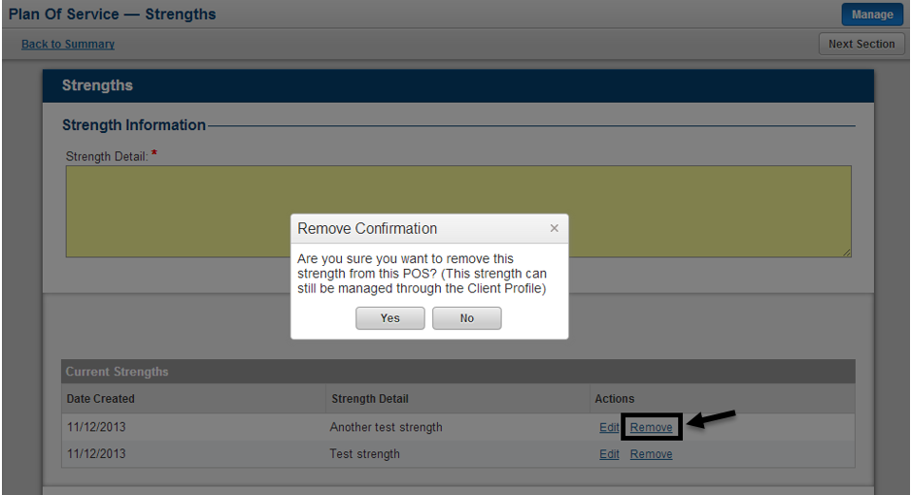

The user can navigate to the following section of the Plan of Service by clicking the Next Section button as seen in the figure below. The user also has the option to navigate directly toany specific section in the Plan of Service by using the left hand navigation as seen in the figure below.

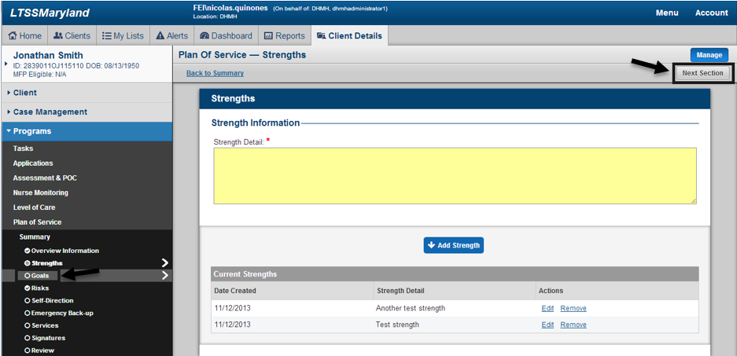

#### Goals

By default the Goals list within a Plan of Service that does not have a decision of Approve or Deny will contain all of the goals listed in the Client Profile that have a Progress status of Not Begun and In Progress. After a decision is made on a Plan of Service the Goals list within that Plan of Service will be locked in and will not change going forward in order to capture an accurate picture of the client goals at the time a decision was made on the POS. Prior to a decision being made an authorized user can make updates to the goals inside the POS by clicking the Manage link on the Goals panel as seen in the figure below.

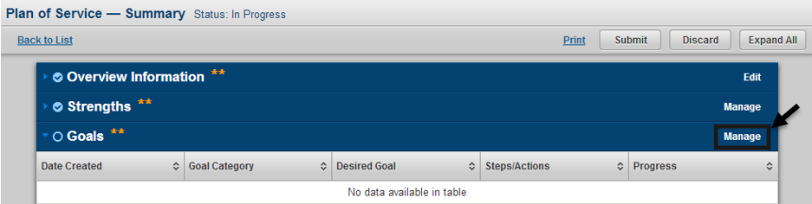

After clicking the Manage link the user will be taken to the Plan of Service Goals page. From this page authorized users will be able to manage all aspects of goals within the Plan of Service. New goals can be added by filling in the required fields and clicking the Add Goal button as seen in the figure below. The user can also edit an existing Goal by clicking the Edit link as seen in the figure below.

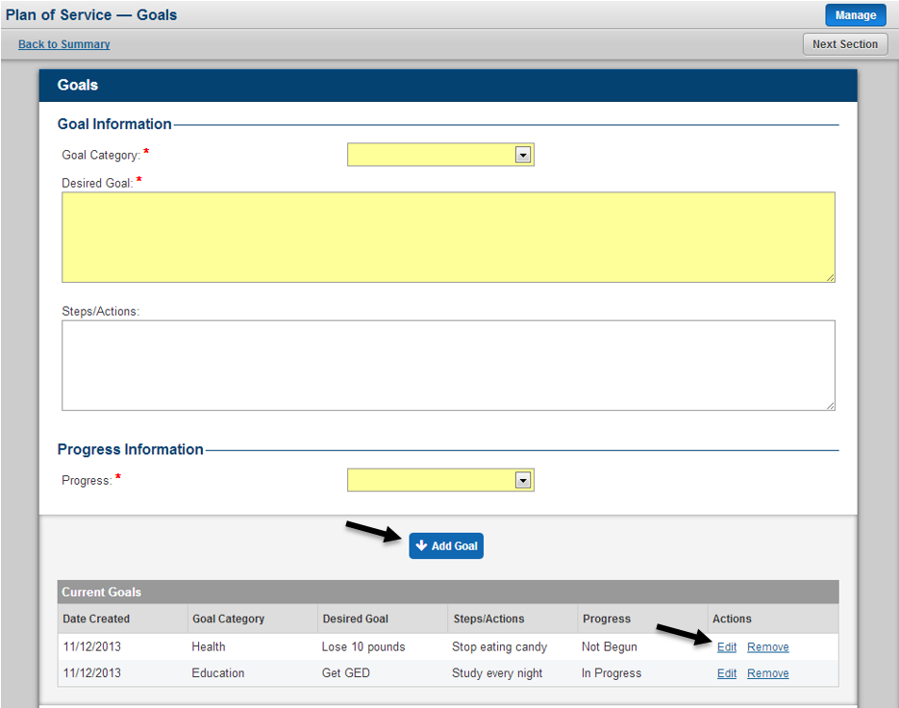

When clicking the Edit link the last saved content for that Goal will be pulled up for the user and will be available for modification. When selecting to edit a goal the specific goal being edited will be highlighted and marked accordingly inside the Current Goals list at the bottom of the page. If changing the Progress for a goal to Achieved or Discontinued an additional field will become available and required. In addition, the user will see a disclaimer message informing them that saving a goal with a Progress of Achieved or Discontinued will remove that goals reference from within the Plan of Service because the POS only references Not Begun and In Progress goals. Achieved and Discontinued goals can still be managed from the Client Profile Goals list. While in edit mode,the user can either choose to cancel making edits by clicking the Cancel button or can save any edits made by clicking the Save Changes button.

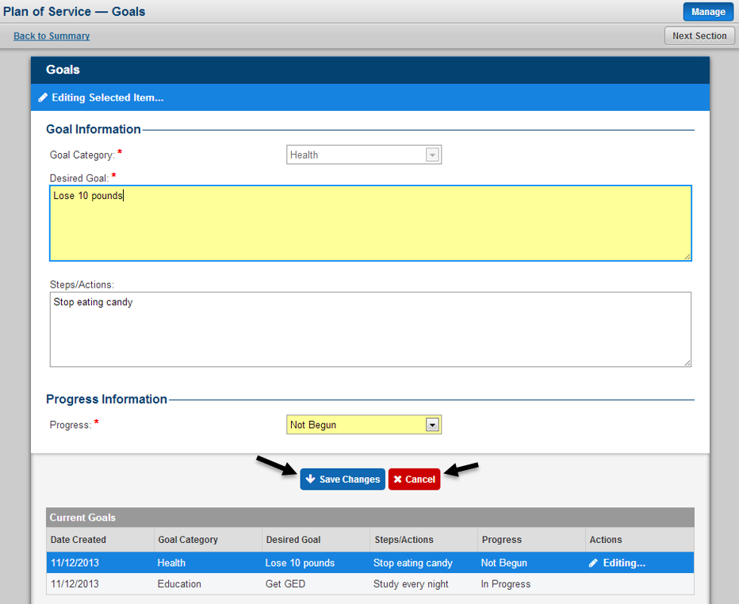

Users will also have the ability to Remove a Goal from within the Plan of Service. The removal of a goal from within the POS will be considered a soft delete, meaning that this will only remove this goals reference from the specific POS and that the goal will still be manageable from the Client Profile Goals list. In order to remove a goal click the Remove link as seen in the figure below. The user will then be prompted to confirm their decision. Click the Yes button to confirm the removal or click the No button to return to the previous page.

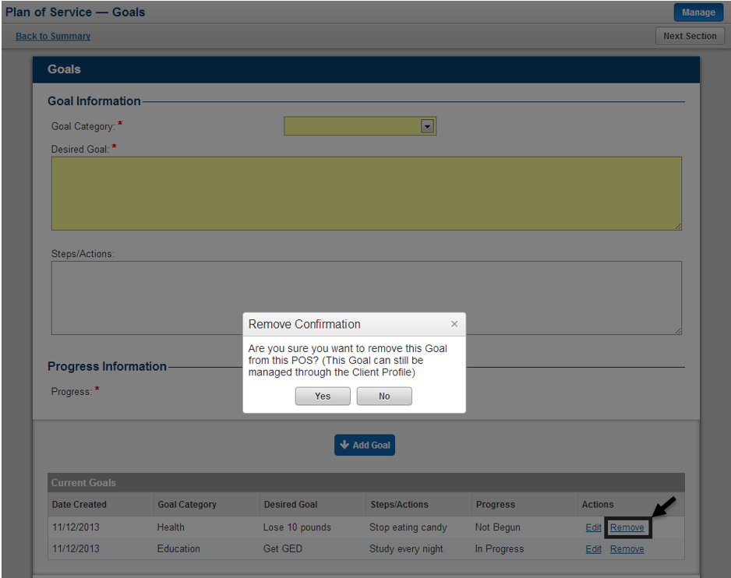

The user can navigate to the following section of the Plan of Service by clicking the Next Section button as seen in the figure below. The user also has the option to navigate directly to any specific section in the Plan of Service by using the left hand navigation as seen in the figure below.

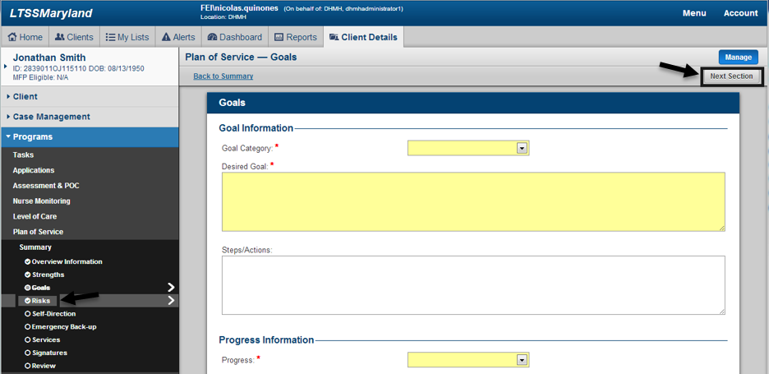

#### Risks

By default the Risks list within a Plan of Service that does not have a decision of Approve or Deny will contain all of the Triggered CAPS from the clients most recent submitted InterRAI Assessment. In the event a POS is started and does not have a decision and a new InterRAI Assessment is submitted for the client with a new set of Triggered CAPS, those Triggered CAPS will replace the existing Triggered CAPS within the Plan of Service. After a decision is made on a Plan of Service the Risks list within that Plan of Service will be locked in and will not change going forward in order to capture an accurate picture of the client risks at the time a decision was made on the POS. Prior to a decision being made an authorized user can make updates to the risks inside the POS by clicking the Manage link on the Risks panel as seen in the figure below.

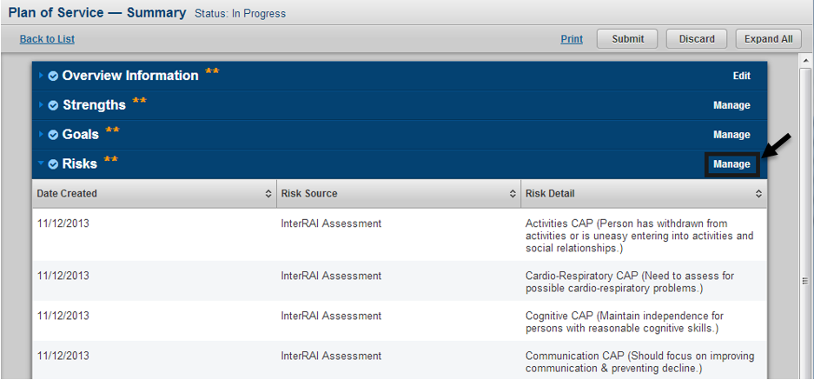

After clicking the Manage link the user will be taken to the Plan of Service Risks page. From this page authorized users will be able to manage all aspects of risks within the Plan of Service. New risks can be added by filling in the required fields and clicking the Add Risk button as seen in the figure below. The user can also edit an existing Risk by clicking the Edit link as seen in the figure below. Risks that come from the InterRAI Assessment cannot be edited, only removed.

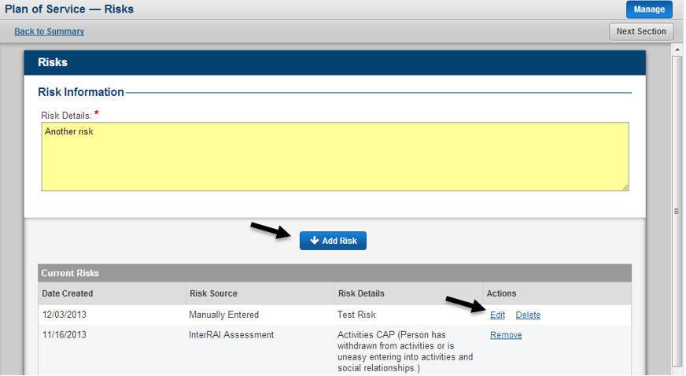

When clicking the Edit link the last saved content for that Risk will be pulled up for the user and will be available for modification. When selecting to edit a risk the specific risk being edited will be highlighted and marked accordingly inside the Current Risks list at the bottom of the page. While in edit mode, the user can either choose to cancel making edits by clicking the Cancel button or can save any edits made by clicking the Save Changes button.

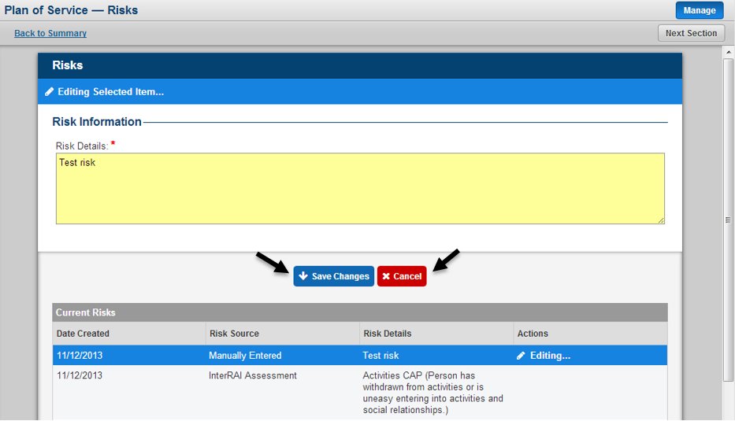

Users will also have the ability to remove a Risk from within the Plan of Service. The removal of a risk from within the POS will be considered a hard delete, meaning that risk will be permanently deleted from the system. In order to remove a risk click the Remove link as seen in the figure below. The user will then be prompted to confirm their decision. Click the Yes button to confirm the delete or click the No button to return to the previous page.

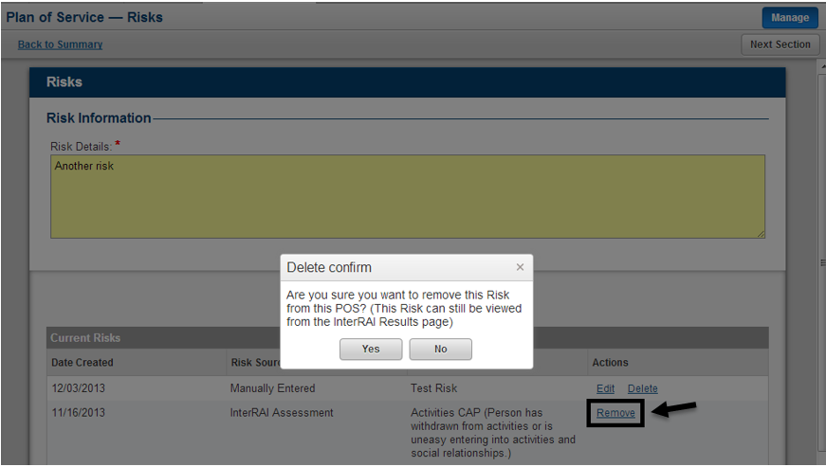

The user can navigate to the following section of the Plan of Service by clicking the Next Section button as seen in the figure below. The user also has the option to navigate directly to any specific section in the Plan of Service by using the left hand navigation as seen in the figure below.

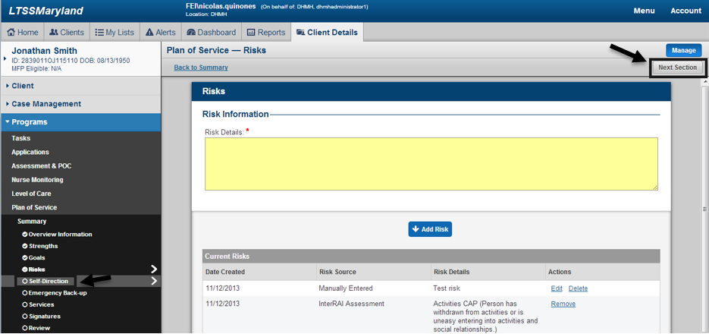

#### Self-Direction

By default the Self-Direction section of the Plan of Service will be blank. As this is a required section of the POS, the user can make edits to the Self-Direction section by clicking the Edit link as seen in the figure below.

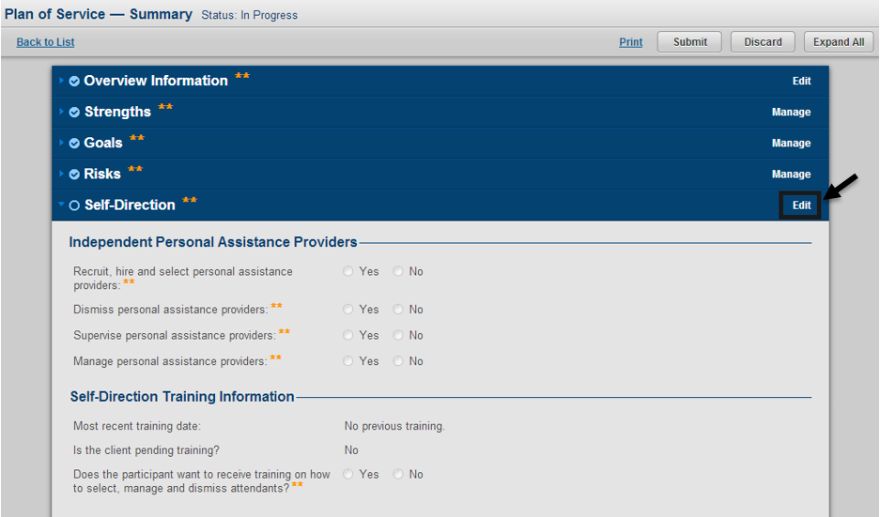

When going to the Self-Direction section all fields will be pre-populated with the answer no. However, these answers can be modified and will not be stored in the Self-Direction section until the user saves the values by clicking the Save or Save & Next buttons as seen in the figure below. When the field “Manage personal support providers” is set to Yes, a subsection will become available to the user. When the field setting payment rate is set to Yes within this subsection, then rate information for the service Personal Assistance Independent will be editable to authorized users if the services is added to that specific Plan of Service. The Training Information portion of the Self-Direction section relates directly to the MDOD Self-Direction Training module in LTSS. The Plan of Service will pull in information from the clients most recent training date or if the client is pending training. Also, if the client is not currently pending training, a referral for MDOD Self-Direction Training can be made through the Plan of Service by answering Yes to the field “Does the participant want to receive training on how to select, manage and dismiss attendant?” When this question is answered Yes, the Plan of Service will generate a referral and an alert to MDOD any time the specific POS is submitted for the first time. An individual POS can generate at most one referral and alert for MDOD Self-Direction training.

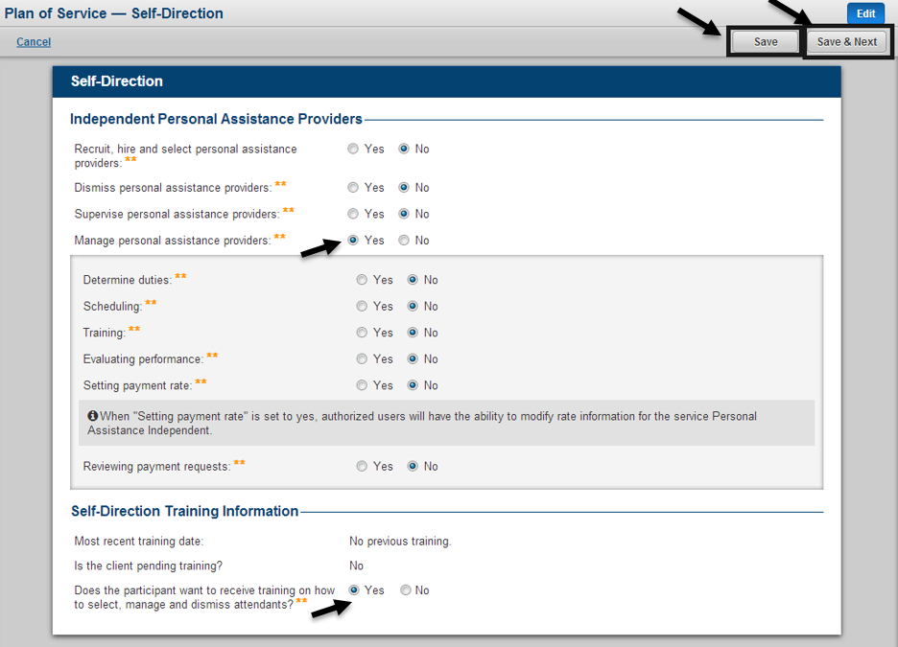

#### Emergency Backup Plans

The Emergency Backup Plans section of the Plan of Service is required in order to submit the overall POS. At least one Emergency Backup must be entered in order to submit the POS. Any time prior to a decision being made on the Plan of Service, an Emergency Backup can be managed by clicking the Manage link on the Emergency Backup Plans panel as seen in the figure below.

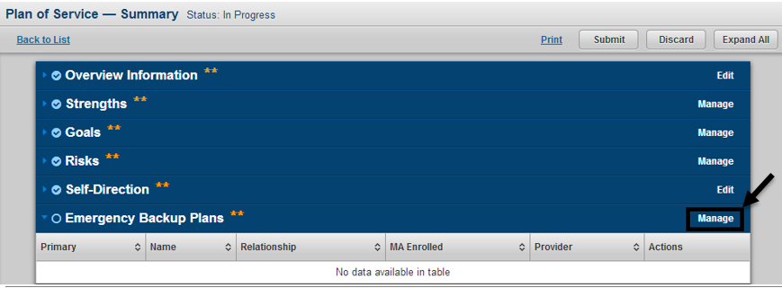

After clicking the Manage link the user will be taken to the Plan of Service Emergency Back-up page. From this page authorized users will be able to manage all aspects of emergency back-ups within the Plan of Service. New emergency back-ups can be added by filling in the required fields and clicking the Add Emergency Back-up button as seen in the figure below. The user can also edit an existing Emergency Back-up by clicking the Edit link as seen in the figure below. There are a few key features within the Emergency Back-up section. First, the user has the ability to add either a Medicaid enrolled Emergency Backup or a Non-Medicaid enrolled Emergency Backup. Based on the users selection for the field is Emergency Back-up Medicaid Enrolled, the form will dynamically change the available fields that must be completed. MA Enrolled Emergency Back-ups will be referenced against specific services in the Service section of the POS, which will be explained in greater detail in the Service section tutorial. Another feature within the Emergency Back-up section is the ability to add multiple phone numbers for a given Emergency Back-up by using the Add Phone button as seen in the figure below.

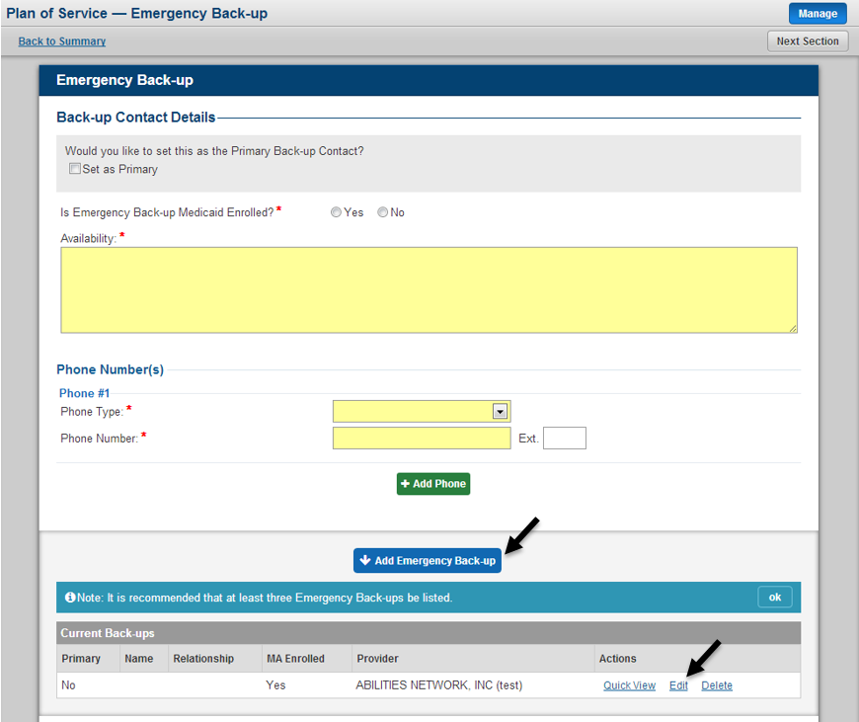

When clicking the Edit link the last saved content for that Emergency Back-up will be pulled up for the user and will be available for modification. When selecting to edit an emergency back-up the specific emergency back-up being edited will be highlighted and marked accordingly inside the Current Back-ups list at the bottom of the page. While in edit mode,the user can either choose to cancel making edits by clicking the Cancel button or can save any edits made by clicking the Save Changes button.

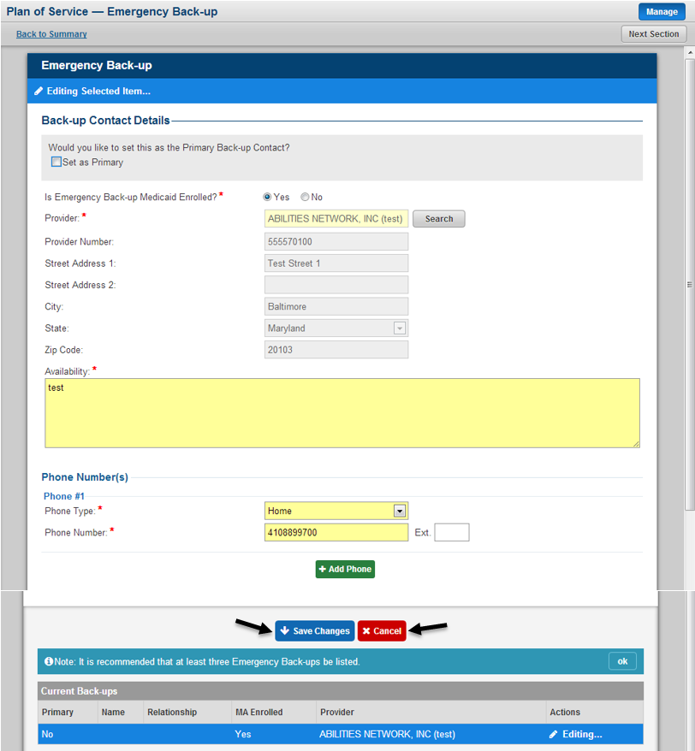

Users will also have the ability to see a quick snapshot of information for a specific Emergency Back-up from within the Plan of Service. In order to see this information click the Quick View link as seen in the figure below. A pop up window will appear showing the summary information for the specific Emergency Back-up. The user can close the pop up window by click the X in the upper right hand corner or by Close button.

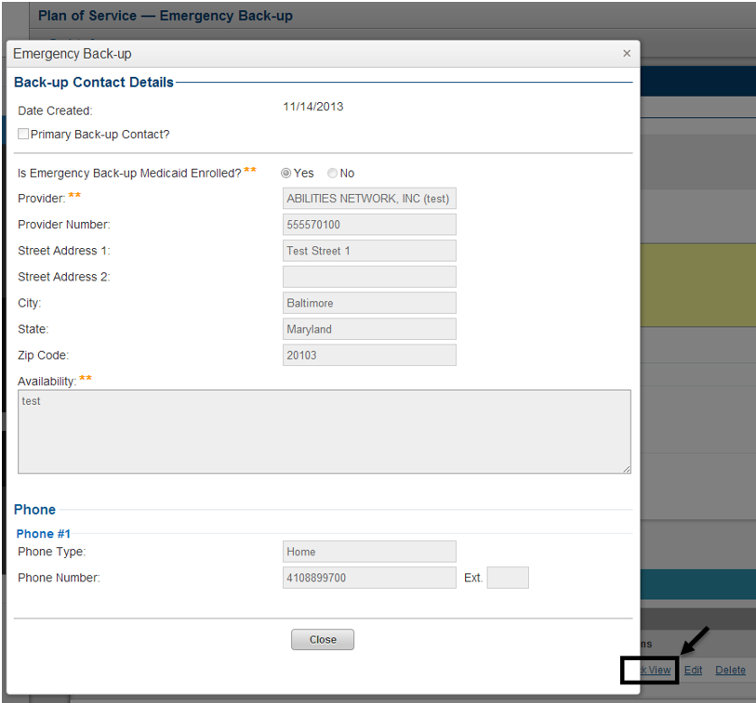

Users will also have the ability to Delete an Emergency Back-up from within the Plan of Service. The deletion of an emergency back-up from within the POS will permanently remove its reference from the specific POS. In order to delete an emergency back-up click the Delete link as seen in the figure below. The user will then be prompted to confirm their decision. Click the Yes button to confirm the delete or click the No button to return to the previous page.

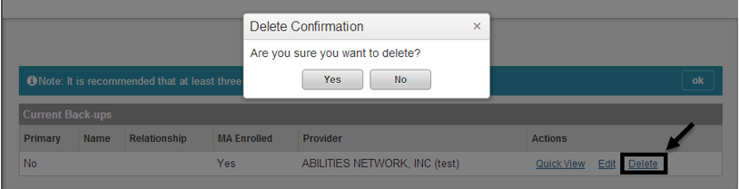

The user can navigate to the following section of the Plan of Service by clicking the Next Section button as seen in the figure below. The user also has the option to navigate directly to any specific section in the Plan of Service by using the left hand navigation as seen in the figure below.

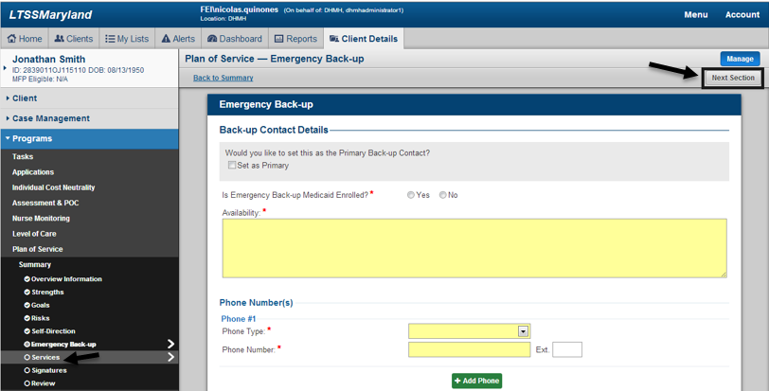

#### Services

The Services section of the Plan of Service is required in order to submit the overall POS. At least one Service must be entered in order to submit the POS. Any time prior to a decision being made on the Plan of Service, a Service can be managed by clicking the Manage link on the Services panel as seen in the figure below.

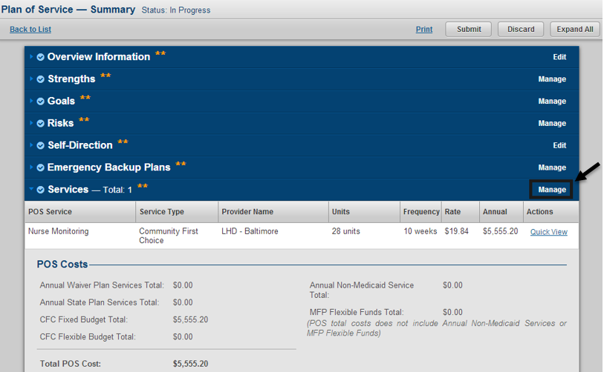

After clicking the Manage link the user will be taken to the Plan of Service - Services page. From this page authorized users will be able to manage all aspects of services within the Plan of Service. New services can be added by filling in the required fields and clicking the Add Service button as seen in the figure below. The user can also edit an existing Service by clicking the Edit link as seen in the figure below.

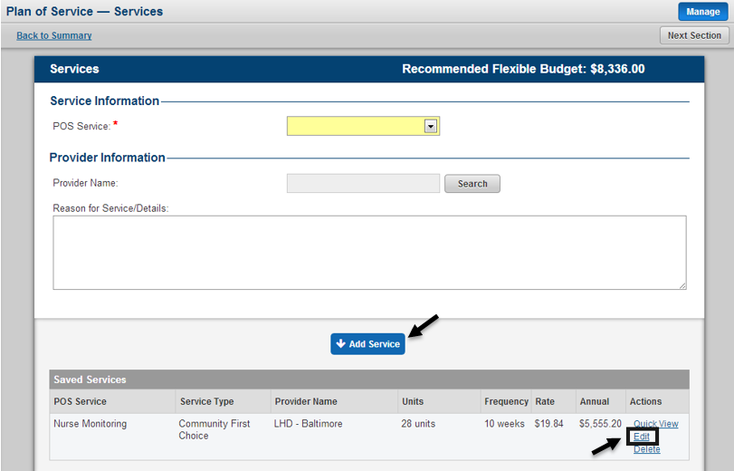

When clicking the Edit link the last saved content for that Service will be pulled up for the user and will be available for modification. When selecting to edit a service the specific service being edited will be highlighted and marked accordingly inside the Saved Services list at the bottom of the page. While in edit mode,the user can either choose to cancel making edits by clicking the Cancel button or can save any edits made by clicking the Save Changes button.

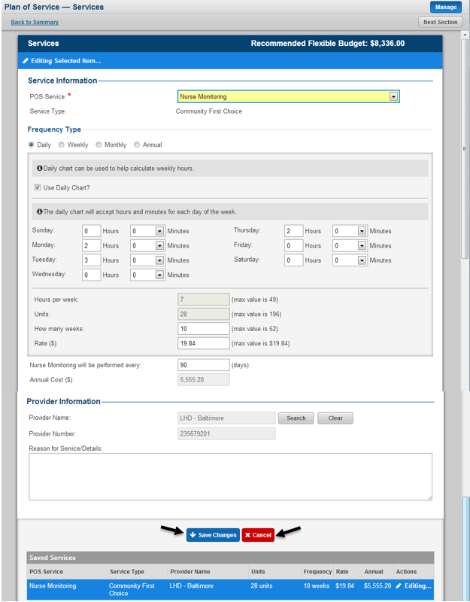

At the top of the Services page, the user will also see the client’s Recommended Flexible Budget. This figure is determined by referencing the client’s latest submitted InterRAI Assessment. Each InterRAI Assessment will produce one Resource Utilization Group (RUG) calculation and this RUG will map to a specific category, which determines the client’s Recommended Flexible Budget.

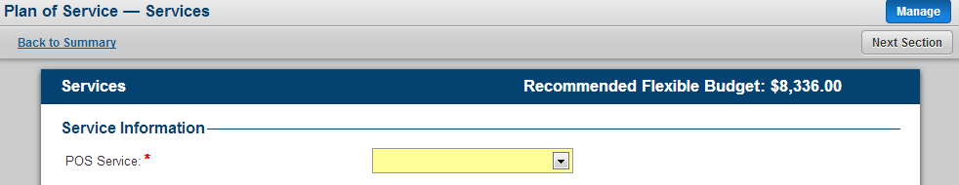

The service that are directly linked to the Recommended Flexible Budget are Personal Assistance Agency, Personal Assistance Independent, Personal Assistance – Shared Attendant, Home Delivered Meals, and Items that substitute for human assistance. Within the POS Service dropdown these service are separated from the other services in order to call out this connection as can be seen in the figure below.

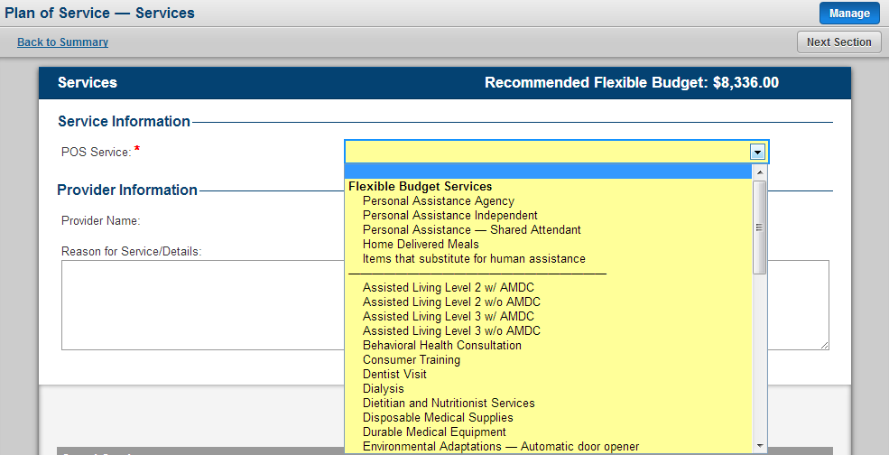

Each individual POS Service has associated Frequency Types available for the input of service data. For example, the POS Service Dentist Visit has Frequency Type options of Weekly, Monthly and Annual. The selection of a specific Frequency Type will drive the additional fields within the Frequency Type section as well as the max values allowable for each field. An example would be that for Dentist Visit if Frequency Type Weekly is selected the user must specify the following: Days per week (max value is 7), How many weeks (max value is 52) and Rate (max value is $1,000). By inputting each individual component LTSS will calculate the Annual Cost field for that service.

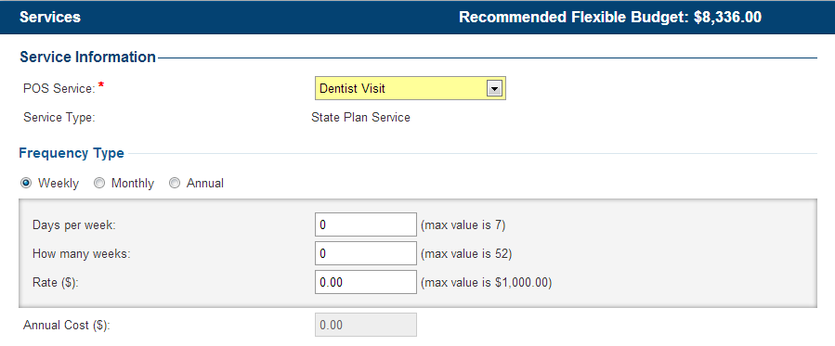

Another unique feature related to Frequency Type for specific services is the ability to use the Daily Chart. When available, by clicking the checkbox for Use Daily Chart as seen in the figure below, the user will be able to enter the number of hours and minutes they plan to provide for each specific day in the week and LTSS will calculate the Hours per week for that service by taking the sum of all the hours for each individual day in the Daily Chart. Once again, there will be default and maximum values allowable based on the Frequency Type selected for the service.

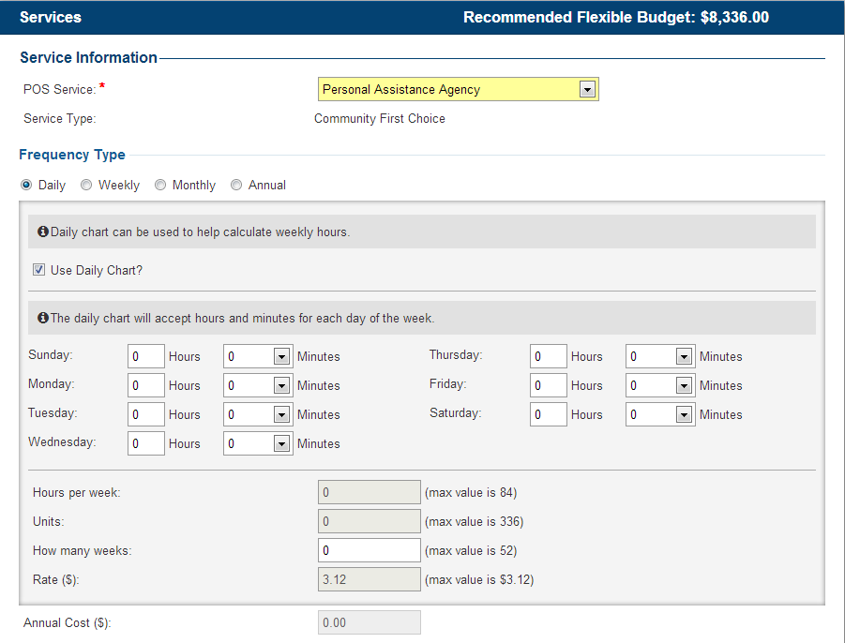

For the POS Service Personal Assistance Independent – Share Attendant, LTSS provided the ability to make a reference to another client in LTSS that the specific client will be sharing the service with. In order identify the client to share the service, the user can use the search functionality which will allow them to search for any client in LTSS. After finding the client and selecting, that clients Client ID will be displayed and a link will be provided that will take the user to that clients Client Summary page as seen in the figure below.

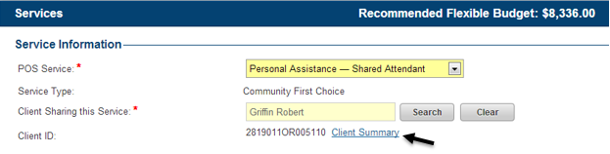

Users will now also have the ability to add MFP Flexible Fund services through the Plan of Service as seen in the figure below. In order to have the ability to add MFP Flexible Fund service in the Plan of Service the client must be MFP Eligible as determined through the client’s latest submitted MFP Questionnaire.

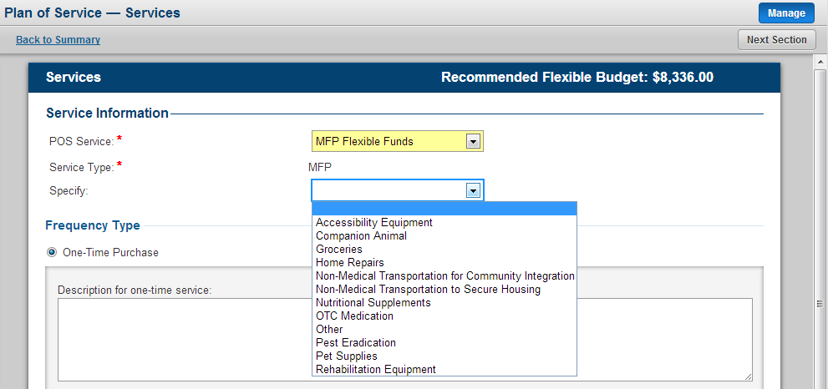

Transition services will also be managed through the Plan of Service. Users can add transition service to any Plan of Service as seen in the figure below.

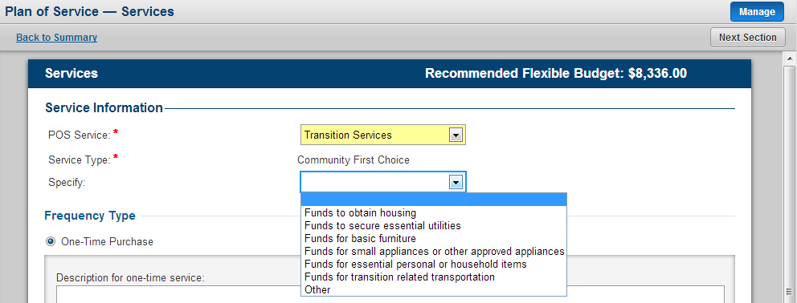

A Plan of Service will only allow for the service Nurse Monitoring to be added to an individual Plan of Service one time. If a user attempts to add this service more than once they will receive an error message as indicated in the screenshot below.

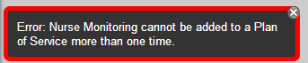

Users will also have the ability to see a quick snapshot of information for a specific Service from within the Plan of Service. In order to see this information click the Quick View link as seen in the figure below. A pop up window will appear showing the summary information for the specific Service. The user can close the pop up window by click the X in the upper right hand corner or by clicking the Close button.

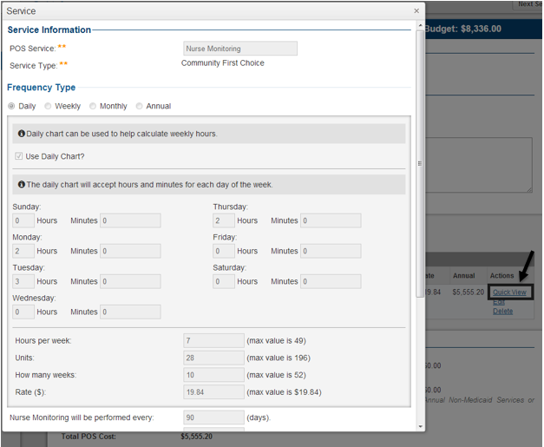

Users will also have the ability to Delete a Service from within the Plan of Service. The deletion of a Service from within the POS will permanently remove its reference from the specific POS. In order to delete a service click the Delete link as seen in the figure below. The user will then be prompted to confirm their decision. Click the Yes button to confirm the delete or click the No button to return to the previous page.

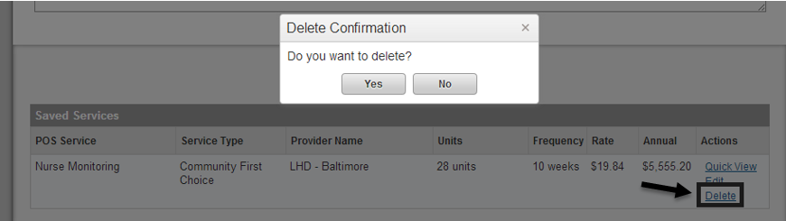

Specific services within the Plan of Service will also have the Emergency Back-ups section. This section pulls from the Emergency Back-up section of the same Plan of Service, but only the MA Enrolled Emergency Back-ups. For these services, all MA Enrolled Emergency Backups listed will have the ability to call in and bill for the service through the ISAS system.

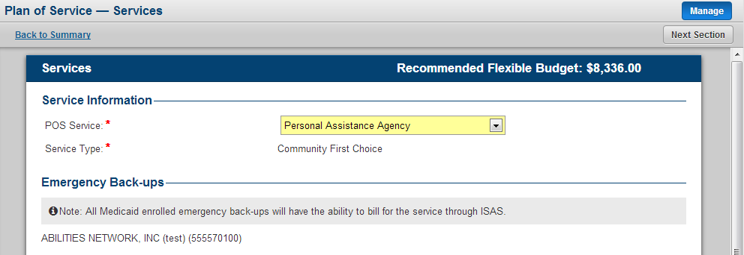

Each service in the POS has an associated Service Type. Each time a service is saved in the POS, the associated Annual Cost will be added to its respective category inside the POS Costs section located at the bottom of the Services page. LTSS will also calculate the Total POS Cost by taking the sum of the Annual Waiver Plan Services Total, Annual State Plan Services Total, CFC Fixed Budget Total and CFC Flexible Budget Total. Based on the Total POS Cost, LTSS will give users an indication of whether or not the specific Plan of Service has gone over the predetermined cost cap for the fiscal year for a POS with Program Type = CO. For an ICS Plan of Service a POS will be determined to be within Cost Neutrality by comparing the Total POS Cost to the Individual Cost Neutrality Cap set for the individual.

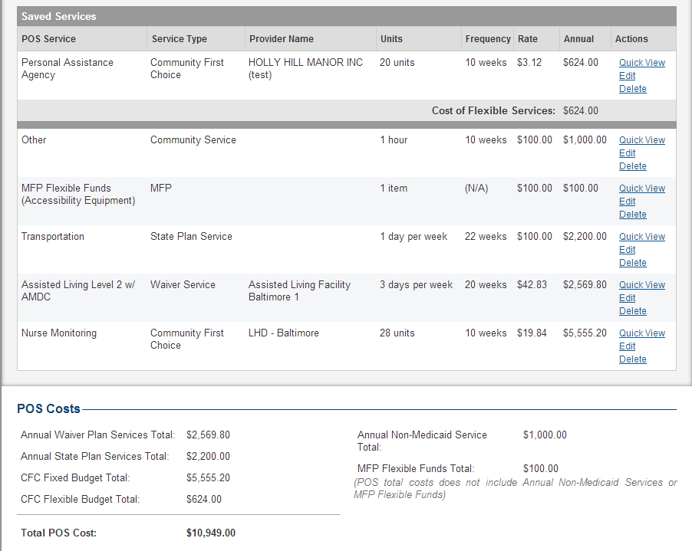

The user can navigate to the following section of the Plan of Service by clicking the Next Section button as seen in the figure below. The user also has the option to navigate directly to any specific section in the Plan of Service by using the left hand navigation as seen in the figure below.

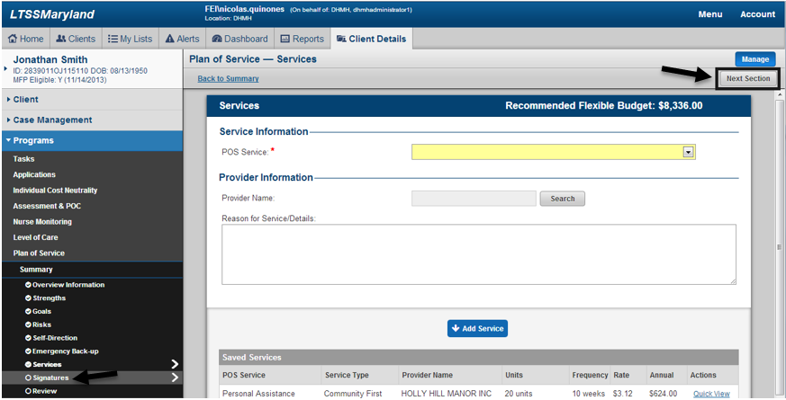

#### Signatures

The Signatures list within a specific Plan of Service will contain a list of all of the unique Providers associated to Services within that POS. All Medicaid Enrolled and Non-Medicaid Enrolled Emergency Backups from the Emergency Backup section of the Plan of Service will also appear in the Signatures list of the Plan of Service. It will also contain the name of the individual client and the clients assigned support planner. Authorized users will have the ability to manage the Signatures section of the Plan of Service at any time. Signature are not required in order to submit or have a decision made on the POS. To make updates to Signature information inside the POS, click the Manage link on the Signatures panel as seen in the figure below.

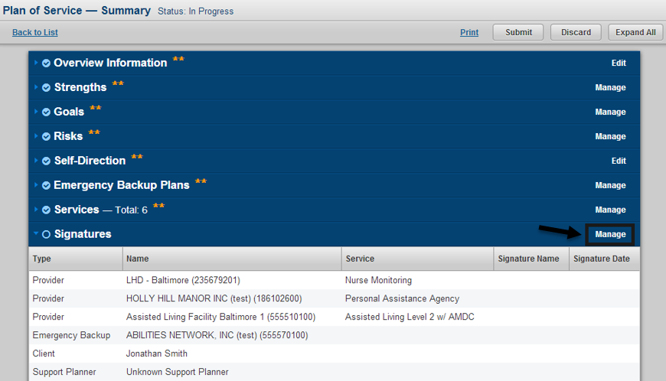

After clicking the Manage link the user will be taken to the Plan of Service Signatures page. From this page authorized users will be able to manage all aspects of Signatures within the Plan of Service. A Signature can be managed by clicking the Sign link as seen in the figure below.

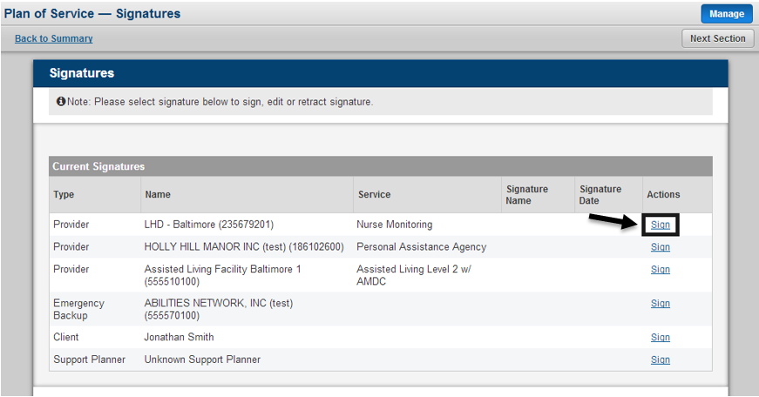

When clicking the Sign link the user will have the ability to enter a Signature Name and Signature. When selecting to edit a signature the specific signature being edited will be highlighted and marked accordingly inside the Current Signatures list at the bottom of the page. While in edit mode, the user can either choose to cancel making edits by clicking the Cancel button or can save by clicking the Add Signature button in the event the Signature Name and Signature Date has not been captured yet.

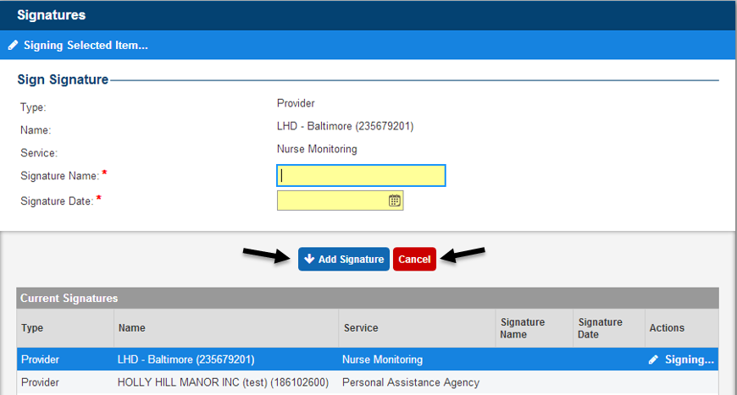

After signature information has been entered the user will have the ability to Edit signature information by clicking the Edit link as seen in the figure below.

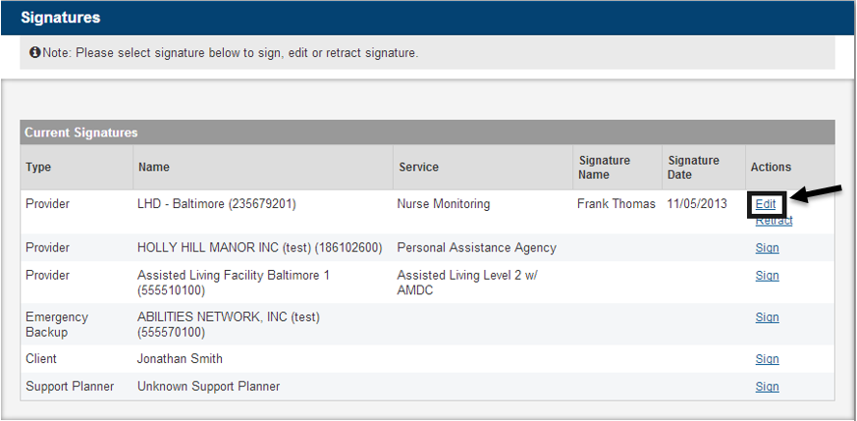

When clicking the Edit link for an entry whose Signature has already been captured the user will be able to edit both the Signature Name and the Signature Date. At any point the user can choose to cancel the edits by clicking the Cancel button or save any changes by clicking the Edit Signature button as seen in the figure below.

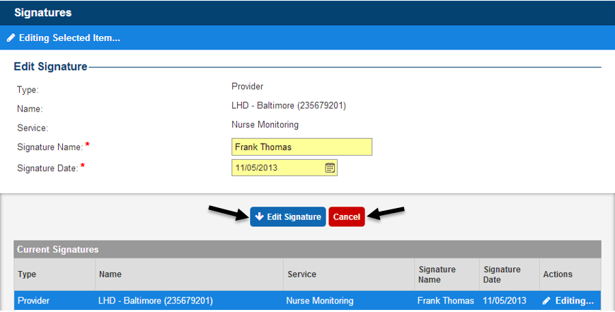

After signature information has been entered the user will have the ability to Retract signature information by clicking the Retract link as seen in the figure below.

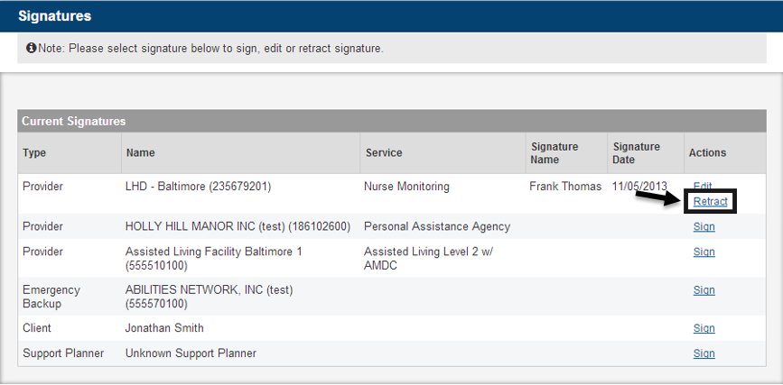

When clicking the Retract link for an entry whose Signature has already been captured the user will be able to retract the entire signature, which essentially acts as a deletion of that signature. At any point the user can choose to cancel the retraction by clicking the Cancel button or proceed with the retraction by clicking the Retract button as seen in the figure below.

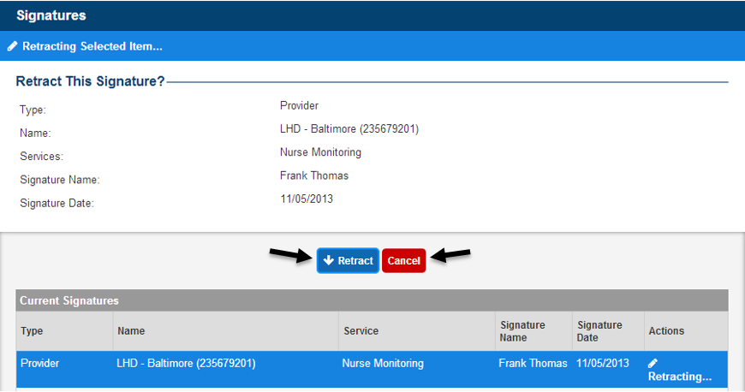

The user can navigate to the following section of the Plan of Service by clicking the Next Section button as seen in the figure below. The user also has the option to navigate directly to any specific section in the Plan of Service by using the left hand navigation as seen in the figure below.

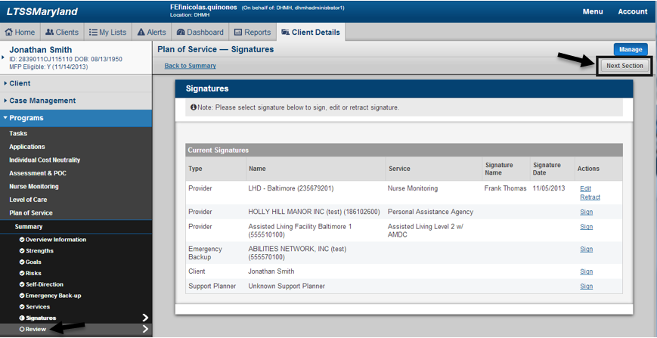

#### Review

The Review section of the Plan of Service summarizes both content within the specific Plan of Service and also information relating to other modules in LTSS for the client. As this is a required section of the POS, the user can make edits to the Review section by clicking the Edit link as seen in the figure below.

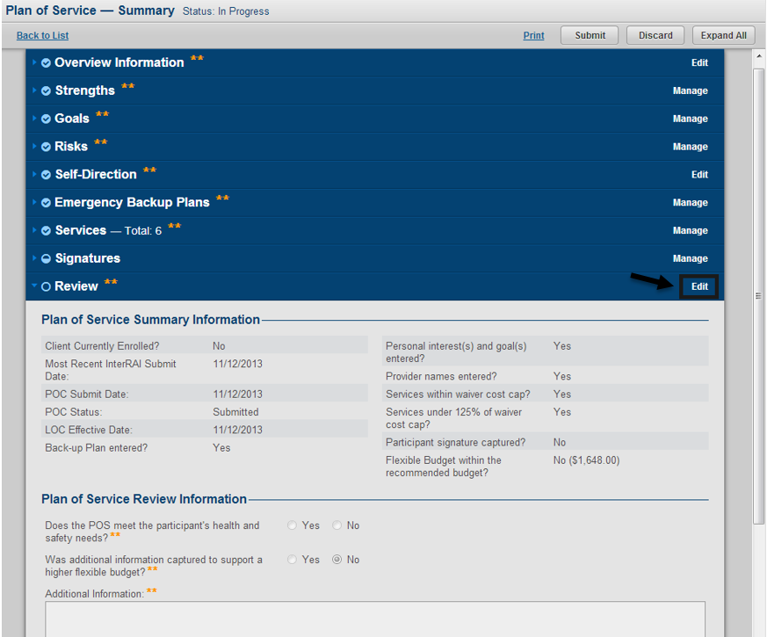

The Review section displays a summary of information about the client and the specific Plan of Service. A critical piece of information in this section related to the field “Flexible Budget within the recommended budget?” This field will give users an indiciation of whether the cost of the Flexible Budget Services within the Plan of Service exceeded the Recommended Flexible Budget. If the answer to the question is No, LTSS will display the amount that the actual cost went over the Recommended Flexible Budget. Also, when the actual Flexible Budget Cost exceeds the Recommended Flexible Budget, users will be required to identify whether additional information was captured to support a higher flexible budget and enter additional comments.

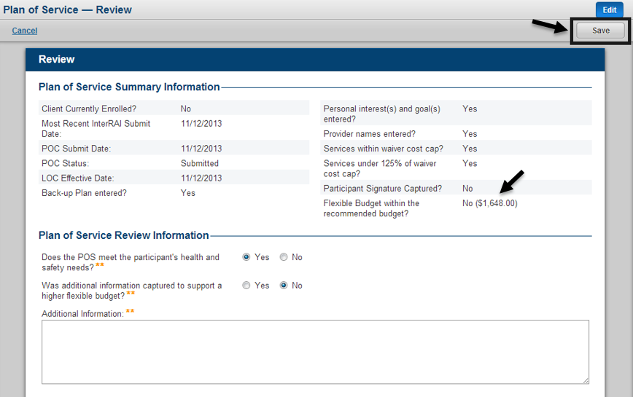

#### Decision and Clarification Requests

The Decision and Clarification Requests section of the Plan of Service gives a snapshot of the POS Status, and when a decision is made on the specific POS it will store the name of the user that made the decision, the decision date and any decision comments entered by the person who made the decision. It also contains a history of all Clarification Requests sent and comments for that specific Plan of Service.

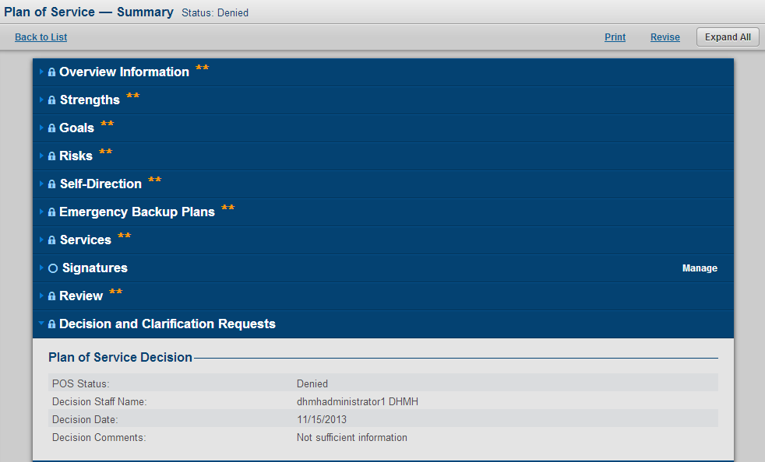

#### Workflow History

The Workflow History section of the Plan of Service will show authorized users the complete audit trail for that Plan of Service, which include information on major actions taken as well as information on the users that took those actions and comments entered. This section of the Plan of Service is only available to authorized users for DHMH.

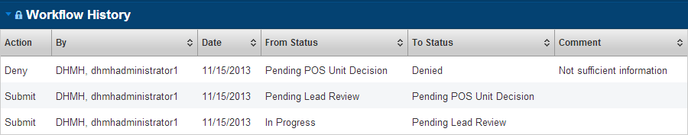

#### Discard Plan of Service

Authorized user also have the ability to discard an entire Plan of Service by clicking the Discard button as seen in the figure below. A Plan of Service can be discarded at any time prior to a decision being made on the Plan of Service. The users capable of discarding a Plan of Service will be dependent on the Status of the overall Plan of Service.

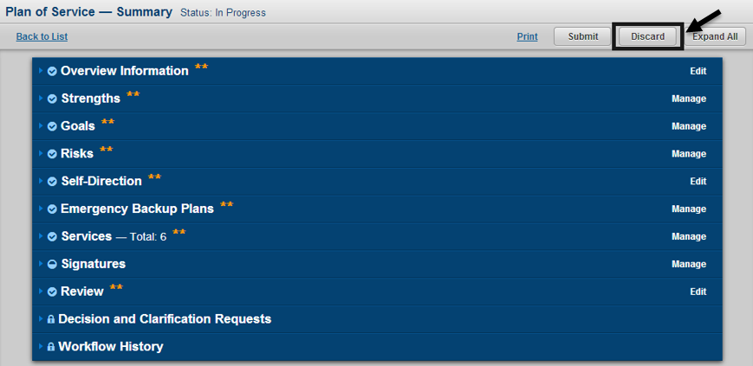

#### Submit Plan of Service for Lead Review

When all required sections/fields within the Plan of Service have been completed the user can submit the Plan of Service by clicking the Submit button as seen in the figure below. This will take the Plan of Service from a Status of In Progress to Pending Lead Review. Also, when submitted an alert will be generated to the Supervisor of the client’s assigned Support Planner as indicated in the Support Planners Staff Profile.

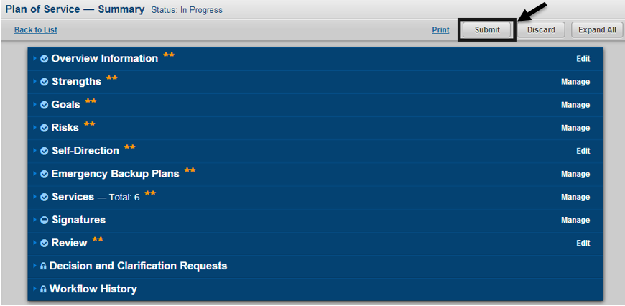

In the event a user tries to submit the Plan of Service without entering all of the required to submit information, LTSS will provide an error message at the bottom of the page informing the user what information is missing. The error message will vary based on what piece(s) of information are missing from the Plan of Service.

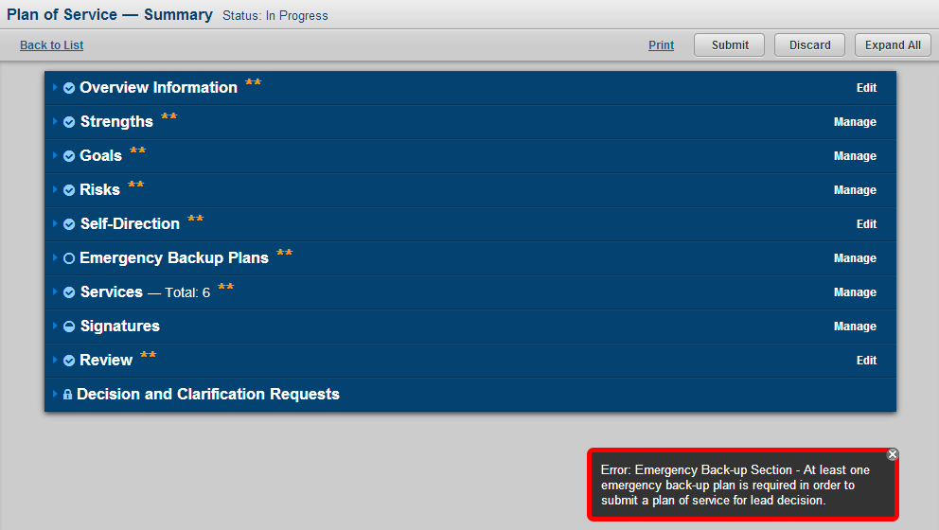

### Plan of Service Pending Lead Review

When a Plan of Service is in a Status of Pending Lead Review all authorized user will have the same capability and functionality that was available when the Plan of Service was In Progress. The major difference is that users with the role of SPA Support Planner will no longer have access to make edits to the Plan of Service, except for in the Signatures section.

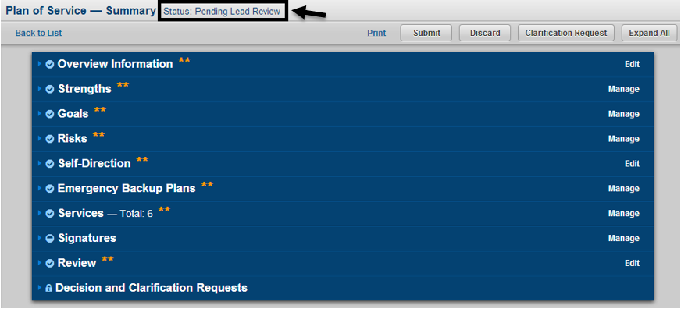

Once the Lead Review is completed any authorized user will have the ability to submit the Plan of Serivce by clicking the Submit button as seen in the figure below. Submitting the Plan of Service while in a Status of Pending Lead Review will send an alert to the clients assigned POS Unit Staff and change the Plan of Service Status to Pending POS Unit Decision.

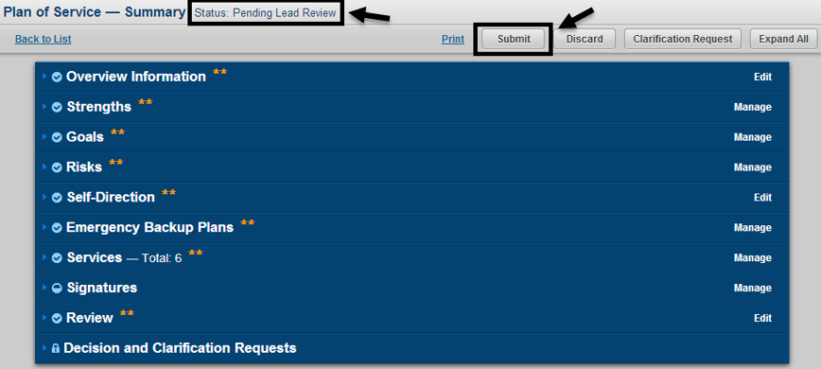

### Clarification Request on Plan of Service

Authorized users will have the ability to submit a clarification request by clicking the Clarification Request button as seen in the figure below. The clarification request functionality can be used when a Plan of Service is in a Status of Pending Lead Review or Pending POS Unit Decision. In order to submit a clarification request the user will be prompted to enter a reason for the clarification request. After entering a reason click the Yes button to submit the clarification request or click the No button to cancel the clarification request.

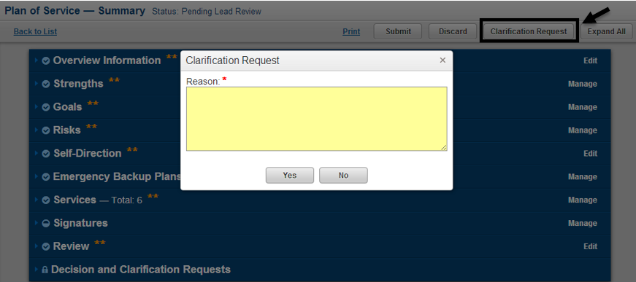

All submitted reasons for a clarification request will be stored in the Clarification Requests table within the Decision and Clarification Requests section of the Plan of Service as seen in the figure below. Each time a clarification request is submitted the name of the user, date and comment will be stored in the table.

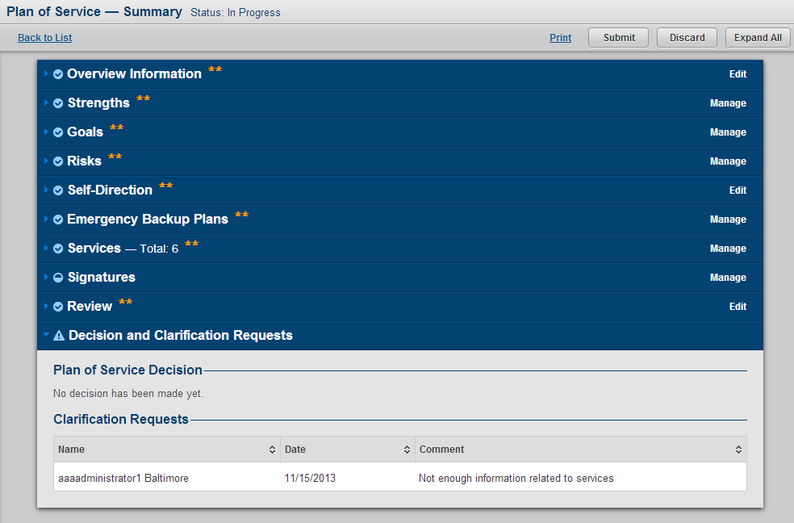

### Plan of Service Pending POS Unit Decision

When a Plan of Service is in a Status of Pending POS Unit Decision all authorized user will have the same capability and functionality that was available when the Plan of Service was In Progress and Pending Lead Review. The major difference is that users with the role of SPA Administrator, SPA Supervisor and SPA Support Planner will no longer have access to make edits to the Plan of Service.

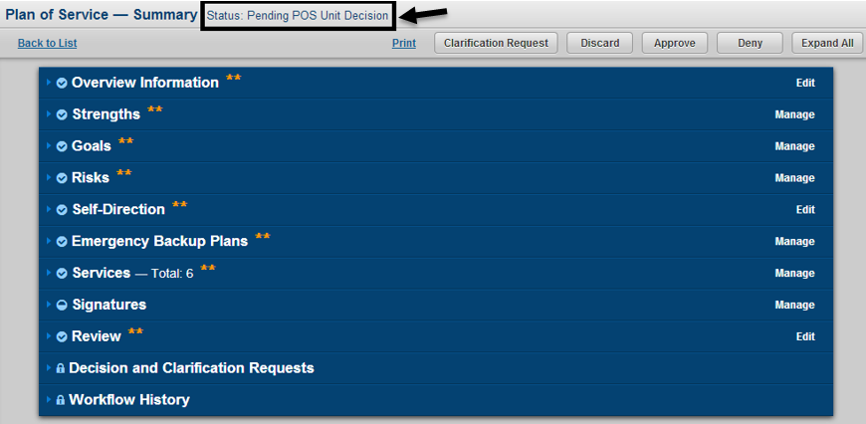

### Plan of Service Decisions

Once the POS Unit Review is completed any authorized user will have the ability to make a decision on the Plan of Service by clicking either the Approve button or Deny button as seen in the figure below.

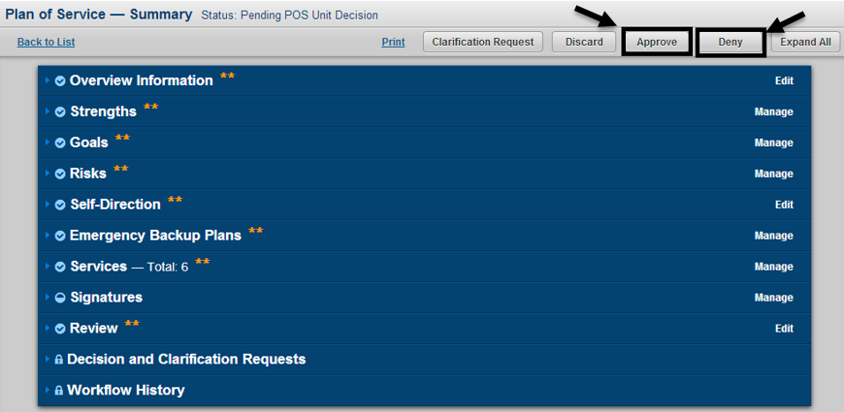

When making a decision on a Plan of Service the user will be prompted to enter comments and confirm their decision as seen in the figure below.

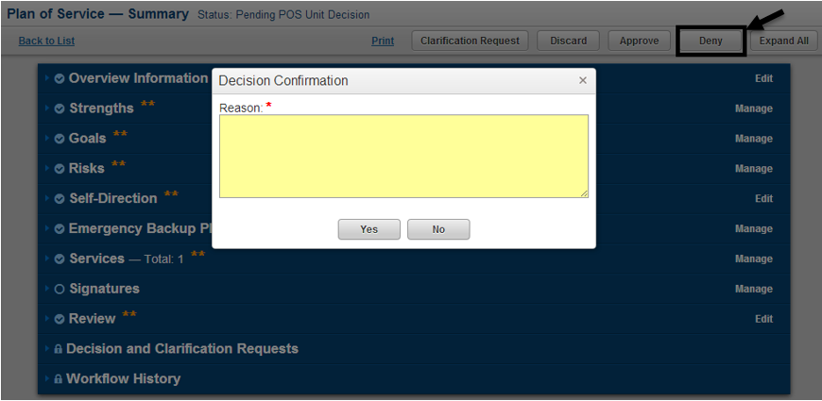

If the user chooses to Deny the Plan of Service, the Status will change to Denied as seen in the figure below. A Denied Plan of Service can be revised in order to make a copy and do any updates necessary in order to take the new Plan of Service back through the decision process. The Revise functionality will be discussed in greater detail in the Revise Plan of Service tutorial in this manual.

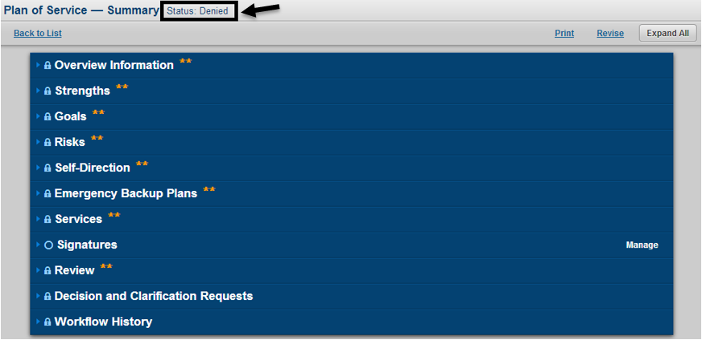

If the user chooses to Approve the Plan of Service with POS Type set as Provisional, the Status will change to Approved for Provisional as seen in the figure below. An Approved for Provisional Plan of Service can be both revised and can go through a conversion process to turn the Provisional Plan of Service in to an Initial, Annual or Revised. The conversion process for a Provisional POS will be discussed in the Convert Provisional Plan of Service tutorial of this manual.

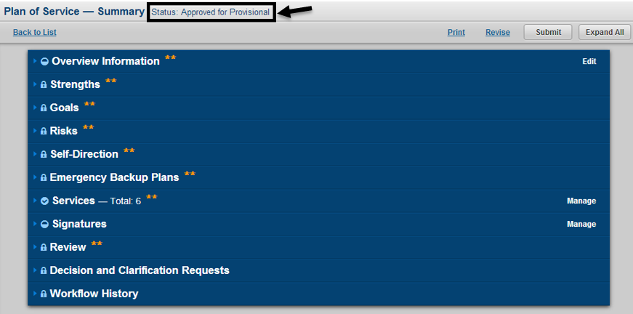

If the user chooses to Approve the Plan of Service with POS Type set as Initial, Annual or Revised, the Status will change to Approved as seen in the figure below. An Approved Plan of Service can be revised in order to make a copy and do any updates necessary in order to take the new Plan of Service back through the decision process. The Revise functionality will be discussed in greater detail in the Revise Plan of Service tutorial in this manual.

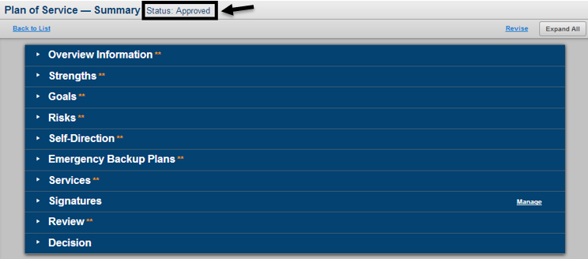

### Converting a Provisional Plan of Service

In order to convert a Provisional Plan of Service, the Plan of Serivce must be in a status of Approved for Provisional. When in this status authorized users will only have access to edit a few select fields that were not previously required when doing a Provisional Plan of Service. In order to start the conversion process click the Edit link on the Overview Information panel in order to change the POS Type as seen in the figure below.

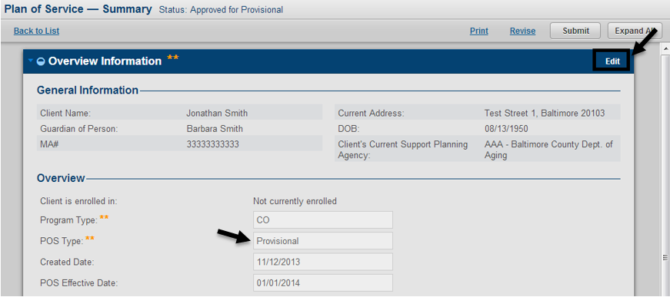

While in Edit mode of the Overview Information section authorized users will be able to change the POS Type and can then enter an Address to Receive Services for the client, which was previously not required when completing a Provisional Plan of Service. After completing the changes click the Save button in order to start the conversion process of the Provisional Plan of Service as seen in the figure below.

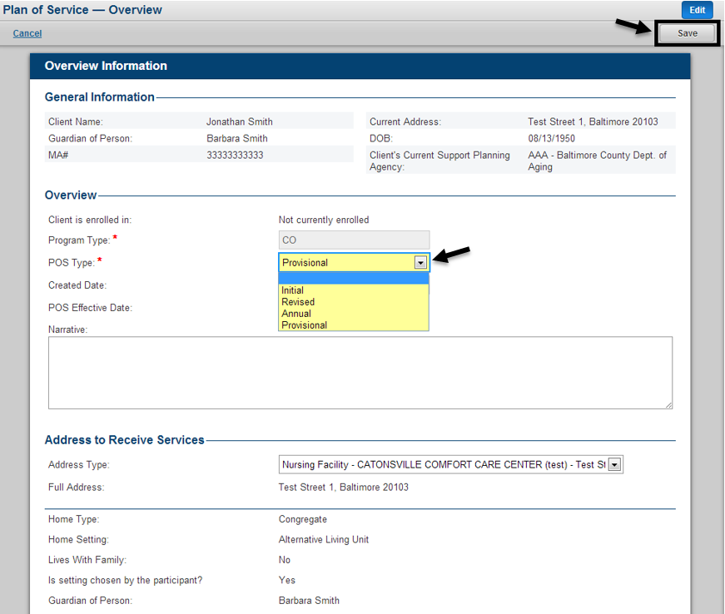

After changing POS Type from Provisional to another POS Type, another piece of information that will be required to complete the conversion process is entering provider information for services that require providers based on service type. To enter provider information for services the user must go to the manage services page by clicking the Manage link on the Services panel as seen in the figure below.

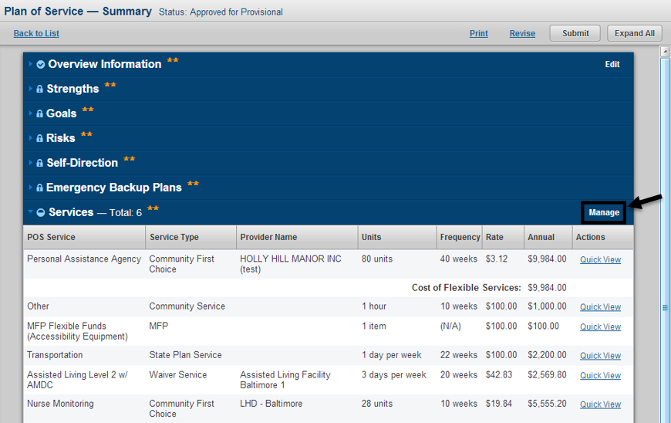

Once the user has completed entering the required information necessary to change a Provisional Plan of Service into another POS Type, the user can submit their changes to convert the Approved for Provisional Plan of Service into an Approved Plan of Service by clicking the Submit button as seen in the figure below. After completing the conversion, that Plan of Service can be considered active if the current system date is greater than or equal to that Plan of Services POS Effective Date.

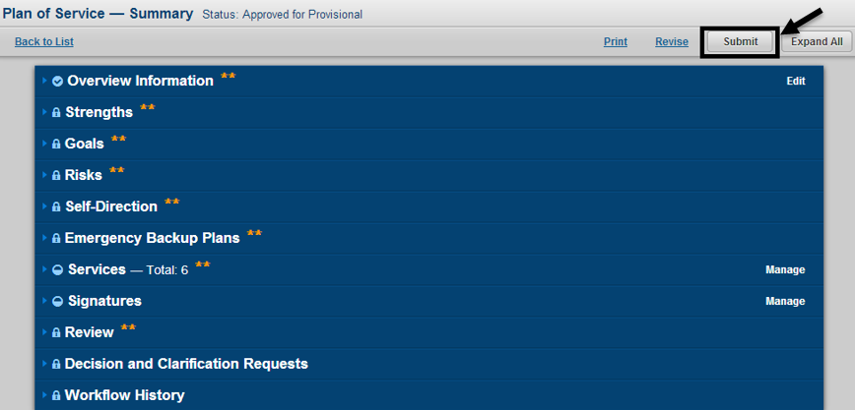

### Print Plan of Service

Authorized users will have the capability to generate a customized print of the Plan of Service by clicking the Print link from the Plan of Service List page as seen in the figure below. When clicking this link a new table will open in the users browser and a PDF will be generated of the selected Plan of Service.

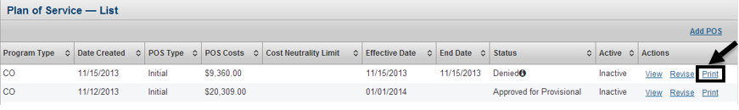

Users will also have the ability to print the Plan of Service from the Plan of Service Summary page as seen in the figure below.

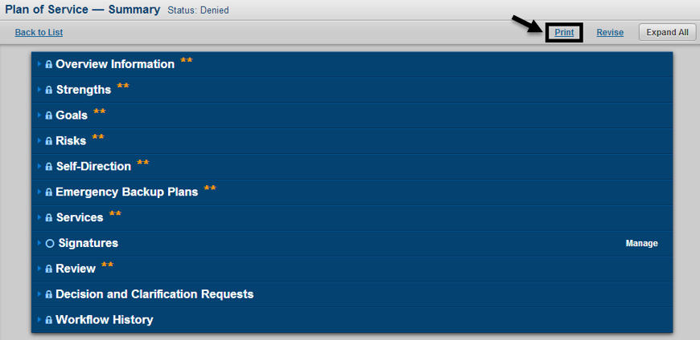

### Revise Plan of Service

The ability to revise a plan of service will be available to all Plans of Service that have a Status of Approved, Approved for Provisional and Denied as long as the client does not have an In Progress, Pending Lead Review or Pending POS Unit Decision Plan of Service. A Plan of Service can be revised by clicking the Revise link from the Plan of Service List page or the Plan of Service Summary page as seen in the figure below. When revising a Plan of Service the user will be prompted to confirm their decision.

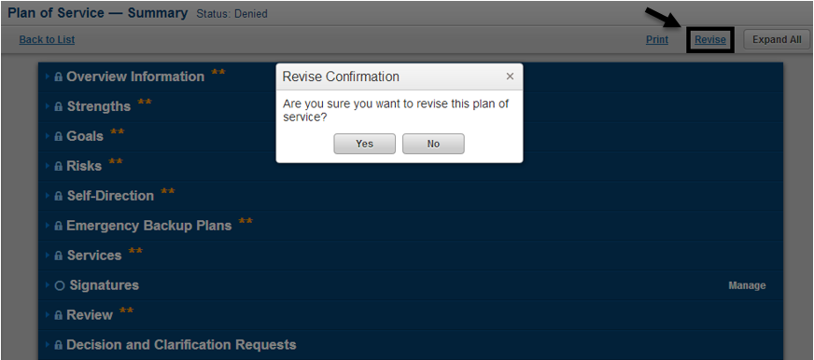

After choosing to Revise a Plan of Service, that Plan of Service will enter a Status of In Progress. All manually entered information from the original Plan of Service will be copied in to the new Plan of Service. All information that is pre-populated or pulled from other parts of the LTSS system, as is done when creating a new Plan of Service will continue to be done for the Revised Plan of Service. The user will then have the capability to manage all sections of the Plan of Service.

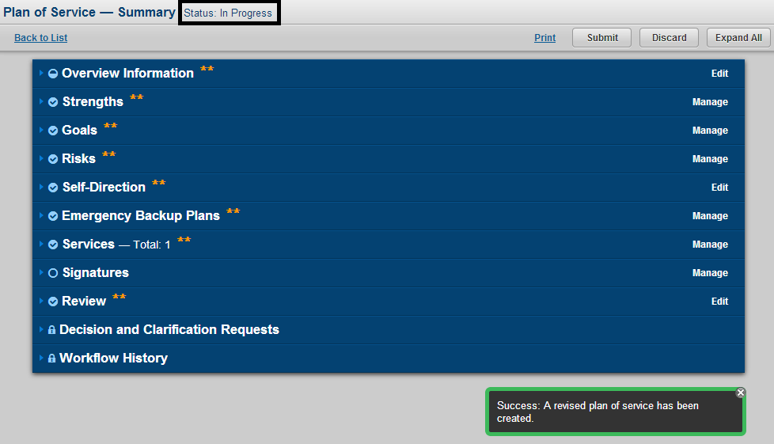

#### Auto-Approval Process for Plan of Service

When a Plan of Serice is revised, the user will have full edit capability. Based on the changes made in the revised Plan of Service, LTSS will determine if that Plan of Service must go back through the normal review and decision process or if an automatic Approval can occur. For an automatic approval to occur all of the rules detailed below must be fulfilled:

1. The Plan of Service selected for revision must be in a status of Approved for Provisional or Approved.
2. No change in frequency for any service in the Plan of Service
3. No change in Total POS Cost Neutrality
4. No change in MFP Flexible Funds Total or no new or removed MFP Flexible Fund service
5. In Review Section of Plan of Service, the field “Does the POS meet the participant’s health and safety needs?” = Yes
6. No Change in Program Type association on the Plan of Service between the original and revised Plan of Service

\***Note**: If any of the above conditions are not satisfied or if the user chooses to Revise a Denied Plan of Service, that revised Plan of Service must always go through the normal review and decision process. Also, if a Plan of Service is Revised and the POS Type is changed to Provisional an automatic approval can still occur, but the Status will become Approved for Provisional and not Approved as Provisional Plans of Service cannot be considered Approved or Active.

### Active vs. Inactive Plan of Service

A client can have at most one Active Plan of Service at a time across all waiver/program types. LTSS will determine the Active Plan of Service by finding the clients most recent Plan of Service with a Status of Approved where the current system date is greater than or equal to the POS Effective Date and less than or equal to the POS End Date. The only exception to this rule is if the clients Active Plan of Service has been manually inactiviated, which will be discussed in detail in the Inactivate a Plan of Service tutorial in this manual.

**Note**: Provisional and Denied Plans of Service can never be considered Active.

A client can have at most one Active Plan of Service at a time across all waiver/program types. LTSS will determine the Active Plan of Service by finding the clients most recent Plan of Service with a Status of Approved where the current system date is greater than or equal to the POS Effective Date and less than or equal to the POS End Date. The only acception to this rule is if the clients Active Plan of Service has been manually inactiviated, which will be discussed in detail in the Inactivate a Plan of Service tutorial in this manual. Note: Provisional and Denied Plans of Service can never be considered Active.


### Inactivate a Plan of Service

LTSS also provides authorized users the ability to manually Inactivate a Plan of Service. Only an Active Plan of Service can be manually inactivated by clicking the Inactivate link as seen in the figure below. The user will then be prompted to enter comments and confirm that they want to inactivate the Plan of Service and can click the Yes button to proceed or the No button to cancel the inactivation.

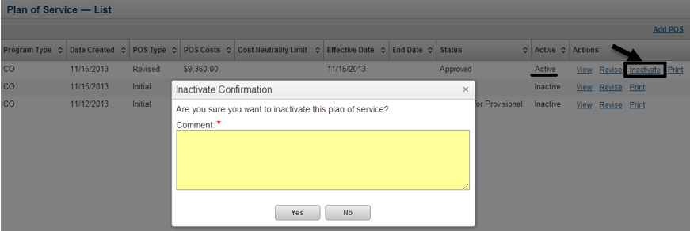

There are two scenarios under which a Plan of Service will get a POS End Date. The first was described through the manual Inactivate process above. When a Plan of Service is manually inactivated that Plan of Service will receive a POS End Date equal to the current system date that the inactivate functionality was used on that Plan of Service. Only for manually inactivated Plans of Service will authorized users have the ability to navigate to the Edit page of the Overview Information section of the Plan of Service and modify the POS End Date as seen in the figure below.

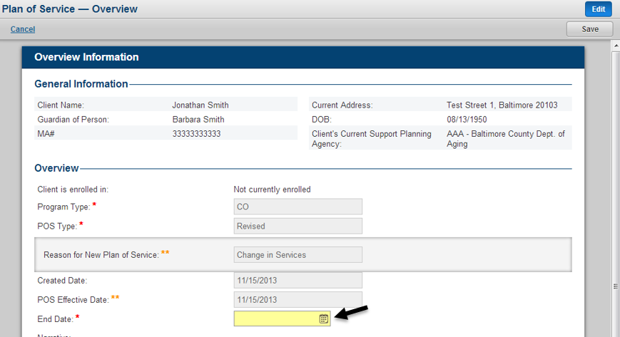

The second scenario under which a Plan of Service will receive a POS End Date is if the client has an Active Plan of Service and then a subsequent Plan of Service is Approved. The approval of the new Plan of Service will set the end date of any current Active Plan of Service by taking the POS Effective Date of the newly approved Plan of Service and subtracting one day. For Plans of Service that receive a POS End Date through this process, the POS End Date field will not be editable to any user.

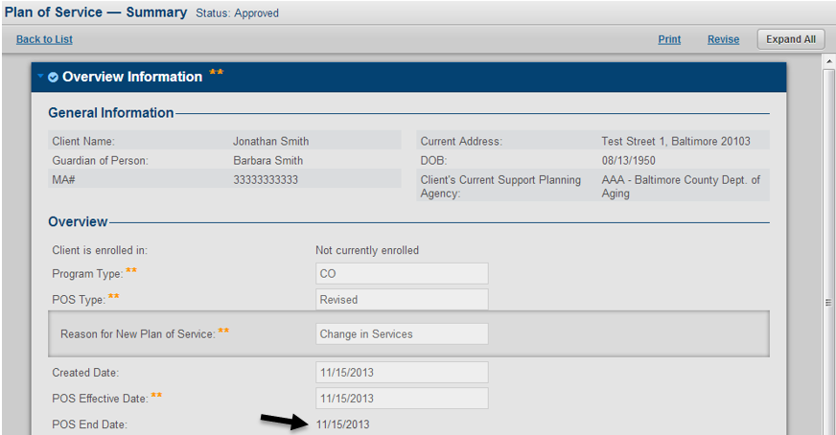

### POS Unit Staff Assignment

Staff with the role of POS Unit Administrator or POS Unit Supervisor will have the ability to assign a POS Unit Staff to an individual client at any time that client has a Plan of Service in one of the following statuses: In Progress, Pending Lead Review or Pending POS Unit Decision. To navigate to the POS Unit Staff Assignment page click the Assignments tab at the top of the page, then select POS Unit Staff Assignment from the left hand navigation. After making this selection the Unassigned POS Unit Staff Assignment list will load. The user can then select the clients they wish to assign a POS Unit Staff member to. After selecting clients, a specific staff with the role of POS Unit Staff can be selected from the Assign to POS Unit Staff dropdown at the bottom of the page. After making all selection, to assign that staff member to the client click the Assign button as seen in the figure below.

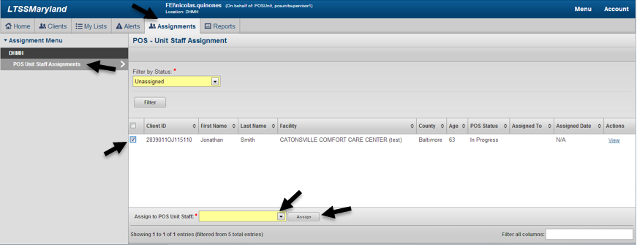

### Plan of Service My Lists

Authorized users will have the ability to run any of the new Plan of Service My Lists by navigating to the My Lists page by clicking the My Lists tab at the top of the LTSS system as seen in the figure below. In order to run a specific Plan of Service My List, click the POS item in the left hand navigation as seen in the figure below. Once on the POS List page, the user can run a variety of My List options, which will require the user to select one Show me and Type option.

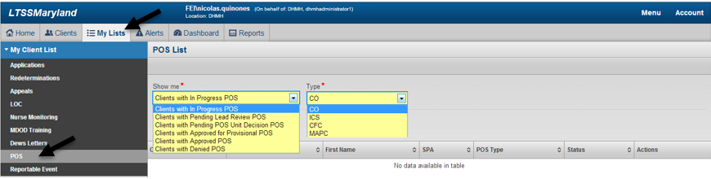

Each specific combination of a Program and Show Me option will produce varying results based on the options selected and the user running the My List. For example, if a user with the role of DHMH Administrator or POS Unit were to run a POS My List for Program = CO and Show Me = Clients with Approved POS, the result would show all those users clients in LTSS whose latest POS has Program Type = CO and Status = Approved. If a user with the role of SPA Administrator or SPA Supervisor were to run the exact same My List options the result of would produce the same results with the exception that only clients with that users SPA agency location as the clients assigned SPA would show up in the results. Finally, if a user with the role of SPA Support Planner were to run the same My List options they would only see clients where that specific SPA Support Planner was assigned to those clients.

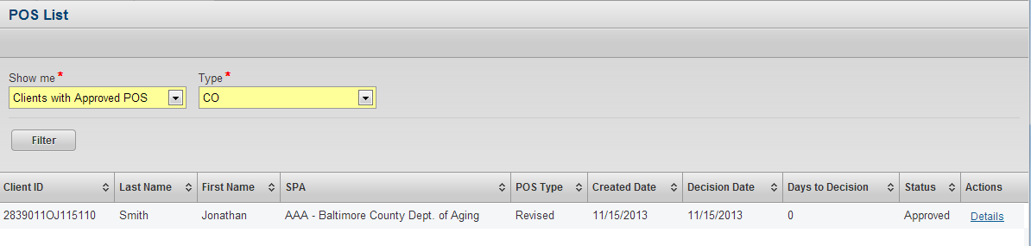

# Appendix

## Plan of Service Connections with Other Modules

|  |  |
| --- | --- |
| **Connected Module** | **Details** |
| Client Profile | When a Plan of Service is created it will pull Strength and Goal information from the Client Profile. |
| InterRAI Assessment | The Plan of Service will pull Resource Utilization Group (RUG) information from the clients InterRAI Assessment in order to determine the Recommended Flexible Budget for the Plan of Service. |
| When a Plan of Service is created it will pulled the Triggered CAPS from the clients latest submitted InterRAI Assessment as Risks within that Plan of Service. |
| MDOD Training | When a Plan of Service is submitted if the field "Does the participant want to receive training on how to select, manage and dismiss attendants?" is set to Yes, then a referral will be generated for the client for MDOD Self Direction Training. |
| Nurse Monitoring | The Due Date for Nurse Monitoring will be set by referencing the field "Nurse Monitoring will be performed every X days" from the clients Active Plan of Service, if that Plan of Service contains the service Nurse Monitoring. |
| ISAS | Providers and MA Enrolled Emergency Backups will be able to call in through ISAS to bill against the following services: Personal Assistance Agency, Personal Assistance Independent and Personal Assistance Shared Attendant. |
| In order for a provider to successfully generate a claim through ISAS and not produce an exception, they must be listed as the Provider of the service they are calling in against within the clients Approved Plan of Service. |
| If calling in for Personal Assistance Shared Attentant, the provider will specify the service and one of the clients utlizing that service. LTSS will identify if that client has this provide approved to provide this service and will identify the individual the client is sharing the service within and generate a claim for each individual. |